Psalm 95 – Common Worship

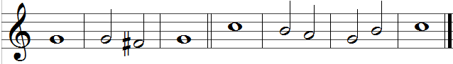

1 O come, let us | sing · to the | Lord;
let us heartily rejoice in the | rock of | our sal-| vation.

2 Let us come into his | presence · with | thanksgiving
and be | glad in | him with | psalms.

3 For the Lord is a | great | God
and a great | king a-| bove all | gods.

4 In his hand are the | depths · of the | earth
and the heights of the | mountains | are his | also.

5 The sea is his, for | he | made it,
and his hands have | moulded · the | dry | land.

6 Come, let us worship and | bow | down
and kneel before the Lord our Maker. | For he | is our | God.

Words taken from Common Worship © The Archbishops’ Council 2000.

