CW Psalm 93
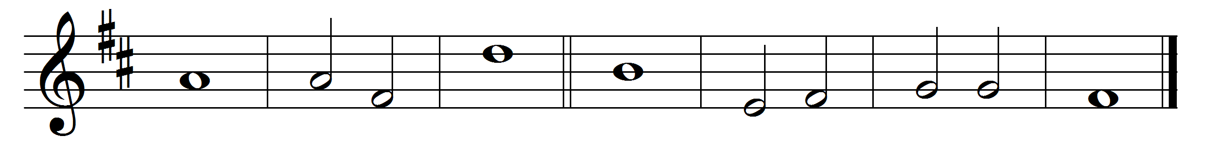
1 The Lord is king and has put on | glorious · ap - | parel; •
the Lord has put on his glory
and | girded ·him - | self with | strength.
2 He has made the whole | world so | sure •
that it | cannot | be | moved.
3 Your throne has been es - | tablished · from of | old; •
you | are from | ever - | lasting.
4 The floods have lifted up, O Lord,
the floods have lifted | up their | voice; •
the floods lift | up their | pounding | waves.
5 Mightier than the thunder of many waters,
mightier than the | breakers · of the | sea, •
the | Lord on | high is | mightier.
6 Your testimonies are | very | sure; •
holiness adorns your | house, O | Lord, for | ever.

Words taken from Common Worship © The Archbishops’ Council 2000.

