Psalm 63, vv. 1-8, Common Worship

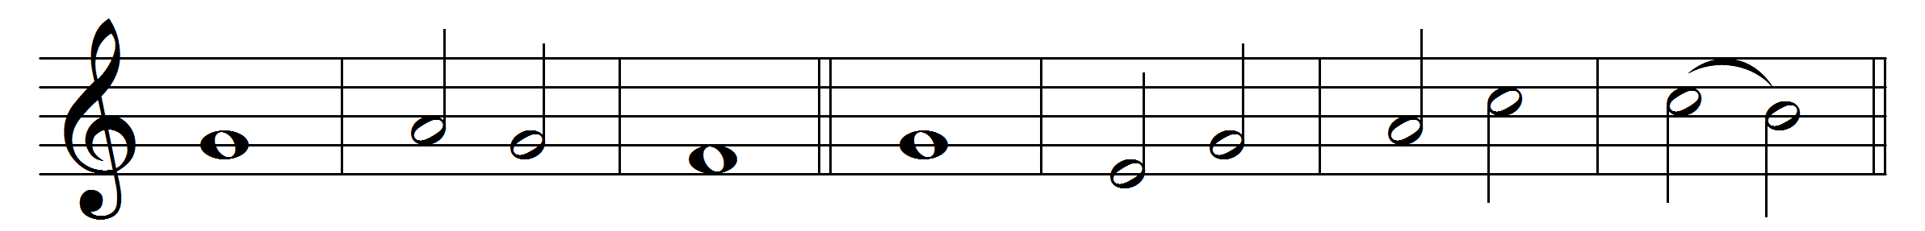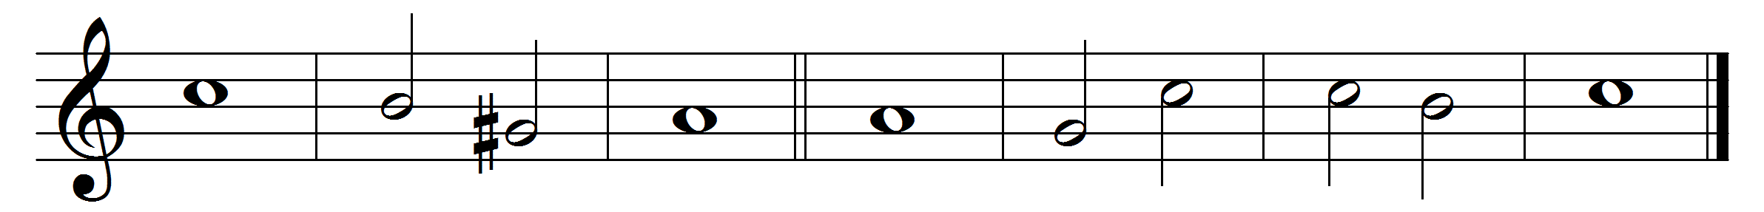
1. O God, you are my God; | eager-· ly I | seek you:
my | soul· is a- | thirst for | you.
2. My | flesh· also | faints for you:
as in a dry and thirsty | land· where there | is no | water.
3. So would I gaze on you in your | holy | place,
that I might be- | hold your | power · and your | glory.
4. Your loving-kindness is better than | life it- | self
and | so my | lips shall | praise you.
5. I will bless you as | long as· I | live
and | lift up· my | hands· in your | name.
6. My soul shall be satisfied, as with | marrow· and | fatness,
and my mouth shall | praise· you with | joyful | lips.
7. When I re- | member· you up- | on my bed
and meditate on you in the | watches | of the | night.
8. For you have | been my | helper
and under the shadow of your | wings will | I re- | joice.

Words taken from Common Worship © The Archbishops’ Council 2000.

