Psalm 29 – Common Worship

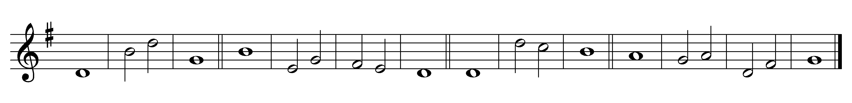

1 Ascribe to the Lord, you | pow’rs of | heav’n,
ascribe to the Lord | glory | and | strength.

2 Ascribe to the Lord the honour | due· to his | name;
worship the | Lord · in the | beauty· of | holiness.

3 The voice of the Lord is upon the waters;
the God of | glory | thunders;
the Lord is up-| on the | mighty | waters.

4 The voice of the Lord is mighty in | oper-| ation;
the voice of the | Lord· is a | glorious | voice.

5 The voice of the Lord | breaks the | cedar trees;
the Lord | breaks the | cedars· of | Lebanon;

6 He makes Lebanon | skip· like a | calf
and Sirion | like a | young wild | ox.

7 The voice of the Lord splits the flash of lightning;
the voice of the Lord | shakes the | wilderness;
the Lord shakes the | wilder-| ness of | Kadesh.

8 The voice of the Lord makes the oak trees writhe
and strips the | forests | bare;
in his | temple | all cry, | ‘Glory!’

9 The Lord sits enthroned a-| bove the | water flood;
the Lord sits enthroned as | king for | ever-| more.

10 The Lord shall give | strength· to his | people;
the Lord shall give his | people· the | blessing· of | peace.

Words taken from Common Worship © The Archbishops’ Council 2000.

