Psalm for 16 September

Psalm 19 vv 1-6

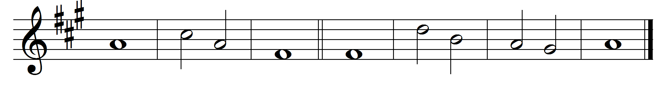
1 The heavens are telling the | glory ·of | God
and the | firmament ·pro- | claims his | handiwork.
2 One day pours out its | song · to an- | other
and one night unfolds | knowledge | to an-| other.
3 They have neither | speech nor | language
and their | voices | are not | heard,
4 Yet their sound has gone out into | all | lands
and their | words · to the | ends · of the | world.
5 In them has he set a tabernacle | for the | sun,
that comes forth as a bridegroom out of his chamber and rejoices as a | champion · to | run his | course.
6 It goes forth from the end of the heavens and runs to the very | end a-| gain,
and there is | nothing | hidden · from its | heat.

Words taken from Common Worship © The Archbishops’ Council 2000.

