Psalm 19

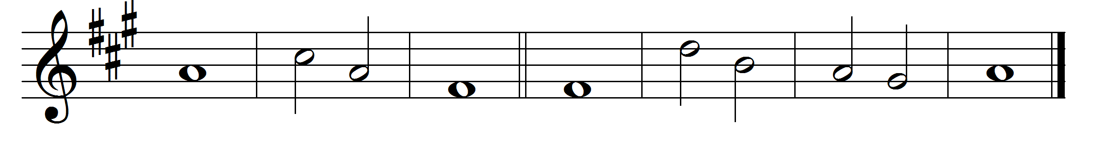
7 The law of the Lord is perfect, re - | viving · the | soul; *
the testimony of the Lord is sure
and gives | wisdom | to the | simple.

8 The statutes of the Lord are right and re - | joice the | heart; *
the commandment of the Lord is pure
and gives | light | to the | eyes.

9 The fear of the Lord is clean and en - | dures for | ever; *
the judgements of the Lord are true
and | righteous | al - to - | gether.

10 More to be desired are they than gold,
more than | much fine | gold, *
sweeter also than honey,
| dripping | from the | honeycomb.

11 By them also is your | servant | taught *
and in keeping them | there is | great re - | ward.

Words taken from Common Worship © The Archbishops’ Council 2000.

