Psalm 136, 1-11 – Common Worship

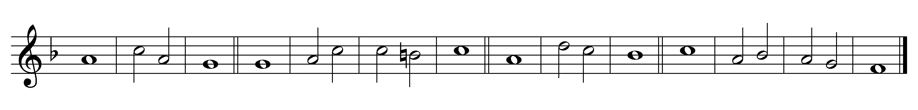

Psalm 136
1 Give thanks to the Lord, for | he is | gracious,
for his | mercy · en - | dures for | ever.

2 Give thanks to the | God of | gods,
for his | mercy · en - | dures for | ever.

3 Give thanks to the | Lord of | lords,
for his | mercy · en - | dures for | ever.

4 Who alone | does great | wonders,
for his | mercy · en - | dures for | ever.

5 Who by wisdom | made the | heavens,
for his | mercy · en - | dures for | ever.

6 Who laid out the earth up - | on the | waters,
for his | mercy · en - | dures for | ever.

7 Who made the | great | lights,
for his | mercy · en - | dures for | ever.

8 The sun to | rule the | day,
for his | mercy · en - | dures for | ever.

9 The moon and the stars to | govern · the | night,
for his | mercy · en - | dures for | ever.

22 A heritage for | Israel · his | servant,
for his | mercy · en - | dures for | ever.

23 Who remembered us when | we were · in | trouble,
for his | mercy · en - | dures for | ever.

24 And delivered us | from our | enemies,
for his | mercy · en - | dures for | ever.

25 Who gives food to | all | creatures,
for his | mercy · en - | dures for | ever.

26 Give thanks to the | God of | heaven,
for his | mercy · en - | dures for | ever.

Words taken from Common Worship © The Archbishops’ Council 2000.

