Psalm 119 vv 65-72 – Common Worship Chant: Anon (taken from the St George’s Chant Book, Berlin, 1887)

On a single stave:
or on two staves, for narrow columns:
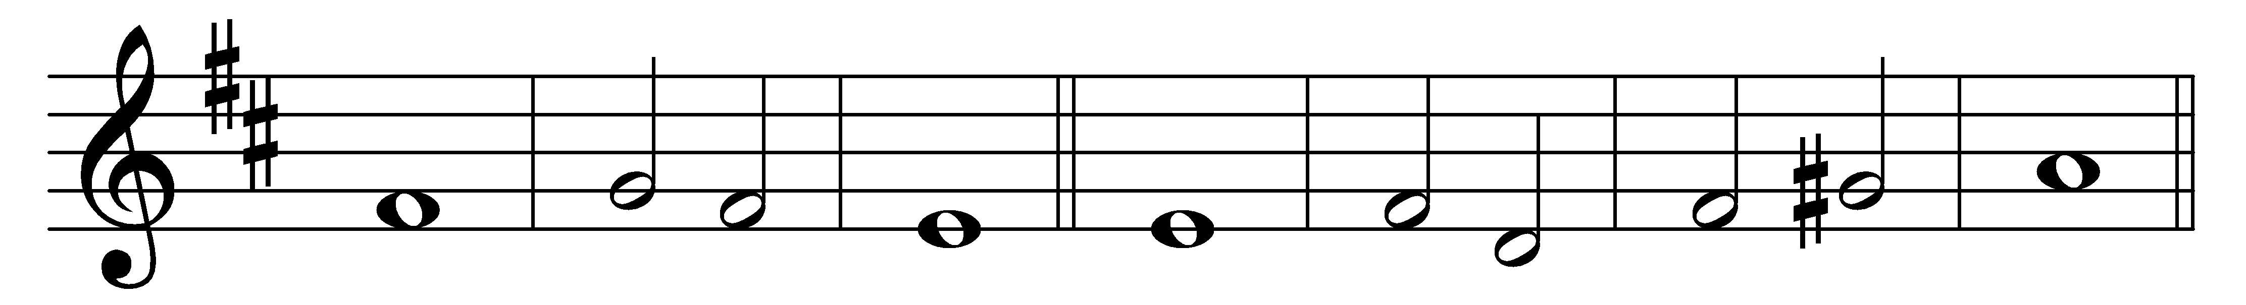
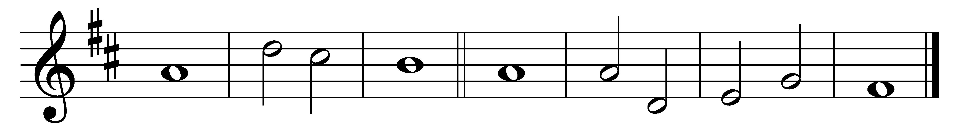

65 You have dealt | graciously· with your | servant,
ac-| cording· to your | word, O | Lord.

66 O teach me true under-| standing· and | knowledge,
for I have | trusted· in | your com-| mandments.

67 Before I was afflicted I | went a-| stray,
but | now I | keep your | word.

68 You are | gracious· and do | good;
O | Lord, teach | me your | statutes.

69 The proud have | smeared me· with | lies,
but I will keep your commandments | with my | whole | heart.

70 Their heart has become | gross with | fat,
but my de-| light is | in your | law.

71 It is good for me that I have | been af-| flicted,
that | I may | learn your | statutes.

72 The law of your mouth is | dearer· to | me ͜
than a | hoard of | gold and | silver.

Words taken from Common Worship © The Archbishops’ Council 2000.

