And can it be? Melody: Sagina
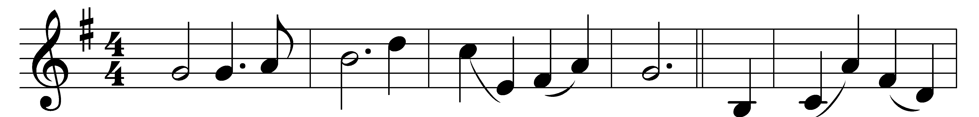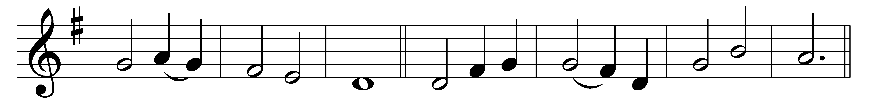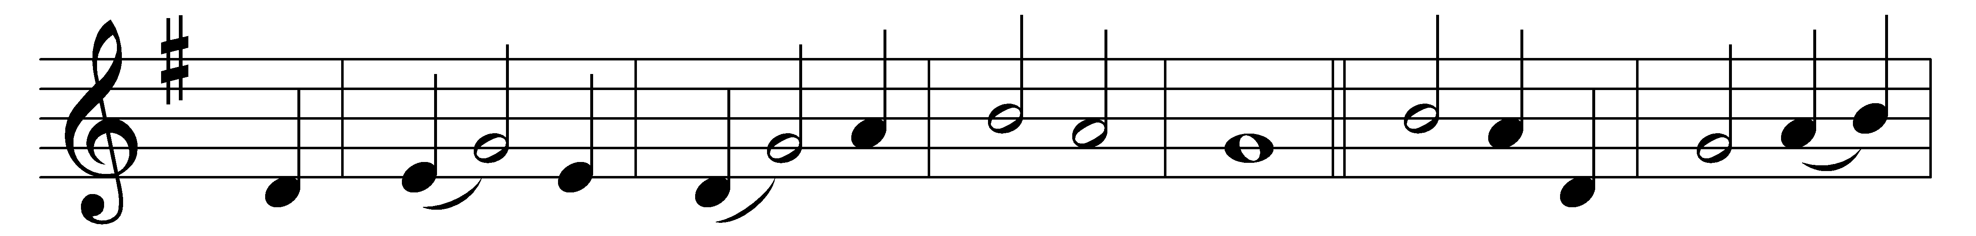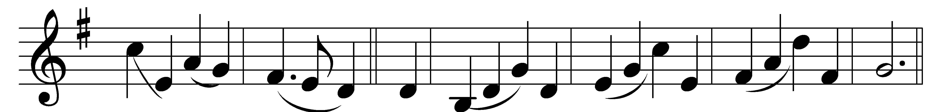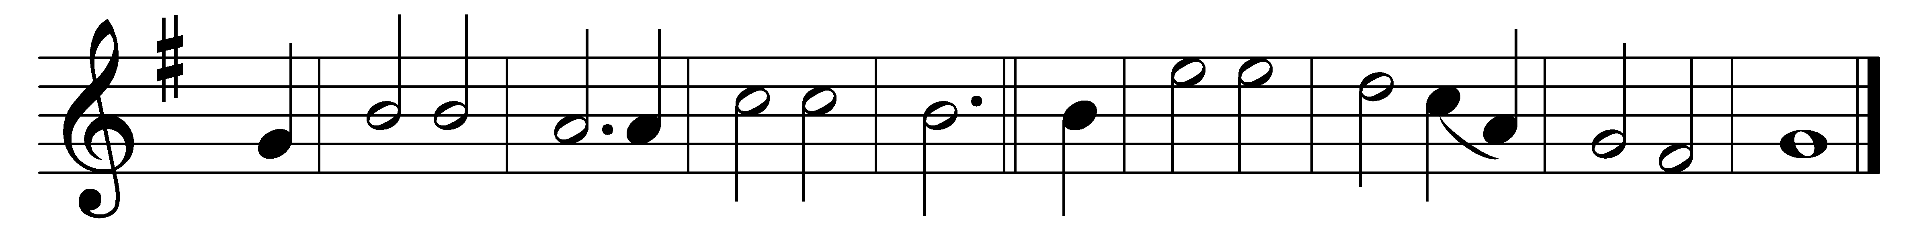

And can it be that I should gain
an interest in the Saviour’s blood?
Died he for me, who caused his pain?
For me, who him to death pursued?
Amazing love! how can it be
that thou, my God, should die for me?
Amazing love! how can it be
that thou, my God, should die for me!

’Tis mystery all! The Immortal dies!
Who can explore his strange design?
In vain the first-born seraph tries
to sound the depths of love divine!
’Tis mercy all! let earth adore,
let angel minds inquire no more.
’Tis mercy all! let earth adore,
let angel minds inquire no more.

He left his Father’s throne above,
so free, so infinite his grace;
emptied himself of all but love,
and bled for Adam’s helpless race;
’Tis mercy all, immense and free;
for, O my God, it found out me.
’Tis mercy all, immense and free;
for, O my God, it found out me.

Long my imprisoned spirit lay
fast bound in sin and nature’s night;
thine eye diffused a quickening ray - ,
I woke, the dungeon flamed with light;
my chains fell off, my heart was free;
I rose, went forth and followed thee.
My chains fell off, my heart was free;
I rose, went forth and followed thee.

No condemnation now I dread;
Jesus, and all in him is mine!
Alive in him, my living Head,
and clothed in righteousness divine,
bold I approach the eternal throne,
and claim the crown, through Christ my own.
Bold I approach the eternal throne,
and claim the crown, through Christ my own.

Words: Charles Wesley (1707-1788)
Music: Thomas Campbell (1825-1876)

