From all that dwell below the skies AMNS 98 Melody: Illsley (Bishop) L.M.
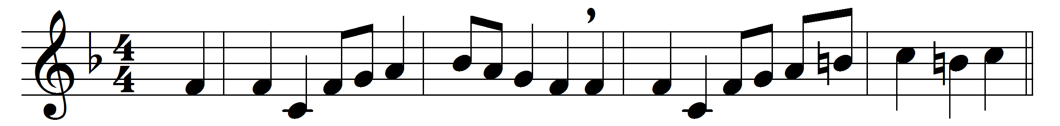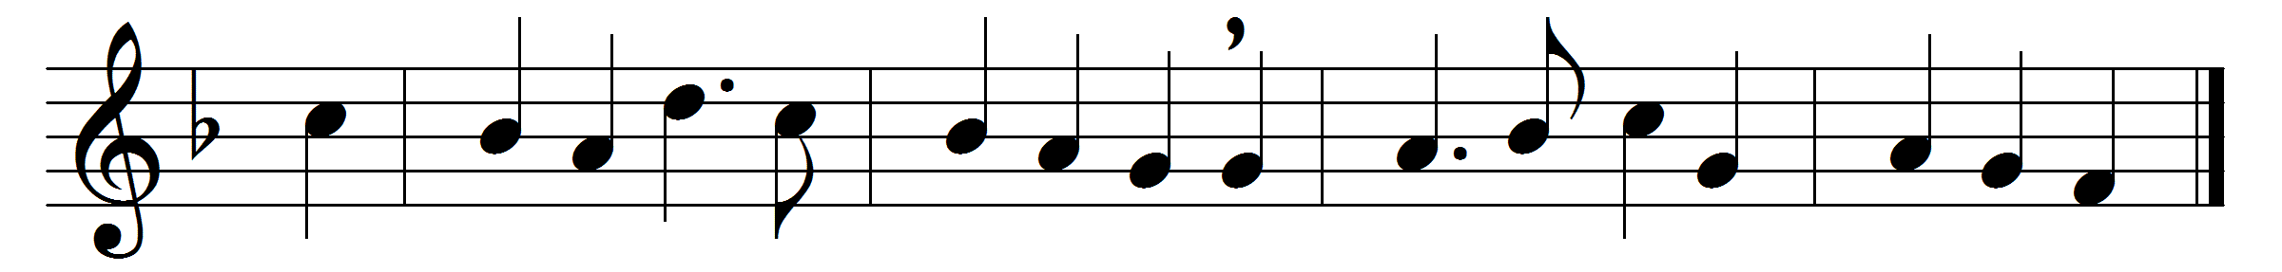

From all that dwell below the skies,
let the Creator’s praise arise:
let the Redeemer’s name be sung
through every land by every tongue.
Eternal are thy mercies, Lord;
eternal truth attends thy word:
thy praise shall sound from shore to shore,
till suns shall rise and set no more.

Words: Isaac Watts (1674-1748)
Music: John Bishop (1665-1737)

