Holy, holy, holy! AMNS 95 Melody: Nicaea 11 12. 12 10.
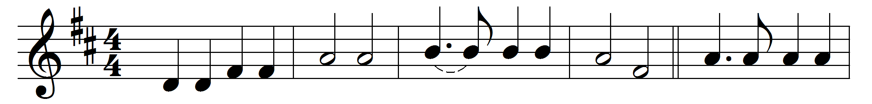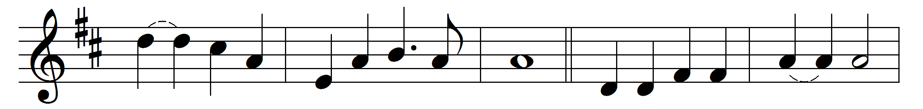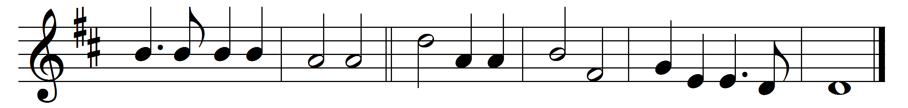

Holy, holy, holy! Lord God Almighty!
early in the morning our song shall rise to thee;
holy, holy, holy! merciful and mighty!
God in three Persons, blessèd Trinity!
Holy, holy, holy! all the saints adore thee,
casting down their golden crowns around the glassy sea;
cherubim and seraphim falling down before thee,
which wert and art and evermore shalt be.
Holy, holy, holy! though the darkness hide thee,
though the eye of sinful man thy glory may not see,
only thou art holy, there is none beside thee
perfect in power, in love, and purity.
Holy, holy, holy! Lord God Almighty!
all thy works shall praise thy name in earth and sky and sea;
holy, holy, holy! merciful and mighty!
God in three Persons, blessèd Trinity!

Words: Reginald Heber (1783-1826)
Music: John Bacchus Dykes (1823-1876)

