Come, Holy Ghost, our souls inspire AMNS 93 Melody: Veni, Creator Spiritus L.M.
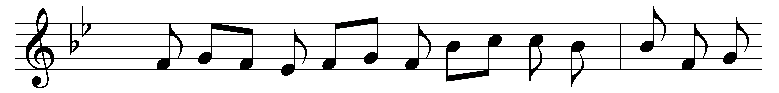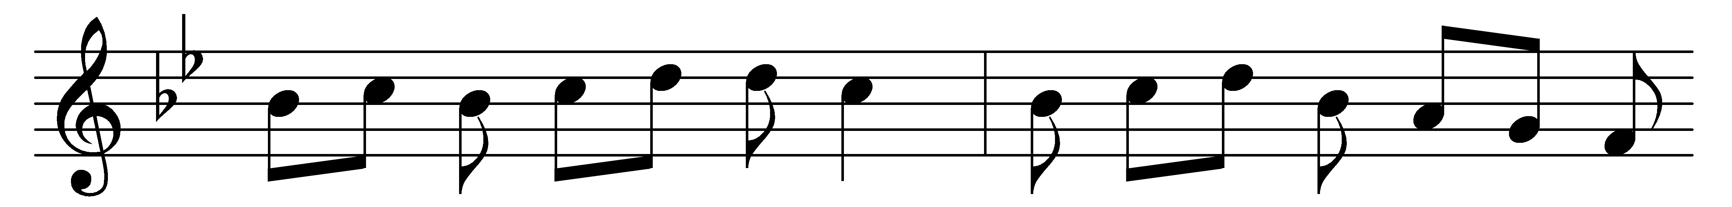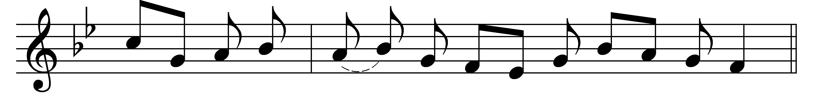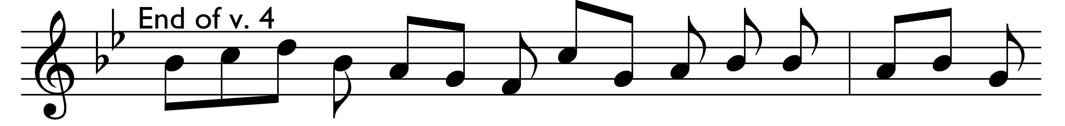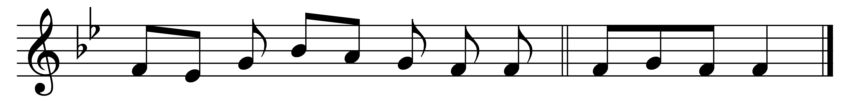

Come, Holy Ghost, our souls inspire,
and lighten with celestial fire;
thou the anointing Spirit art,
who dost thy sevenfold gifts impart.

Thy blessèd unction from above
is comfort, life, and fire of love;
enable with perpetual light
the dullness of our blinded sight.

Anoint and cheer our soilèd face
with the abundance of thy grace:
keep far our foes, give peace at home;
where thou art guide no ill can come.

Teach us to know the Father, Son,
and thee, of both, to be but one;
that through the ages all along
this may be our endless song,
‘Praise to thy eternal merit,
Father, Son, and Holy Spirit.’ Amen.

Words: Latin, paraphrased by John Cosin (1594-1672)
Music: Mode viii

