Jesu, our hope, our heart’s desire AMNS 86 Melody: Metzler’s Redhead C.M.
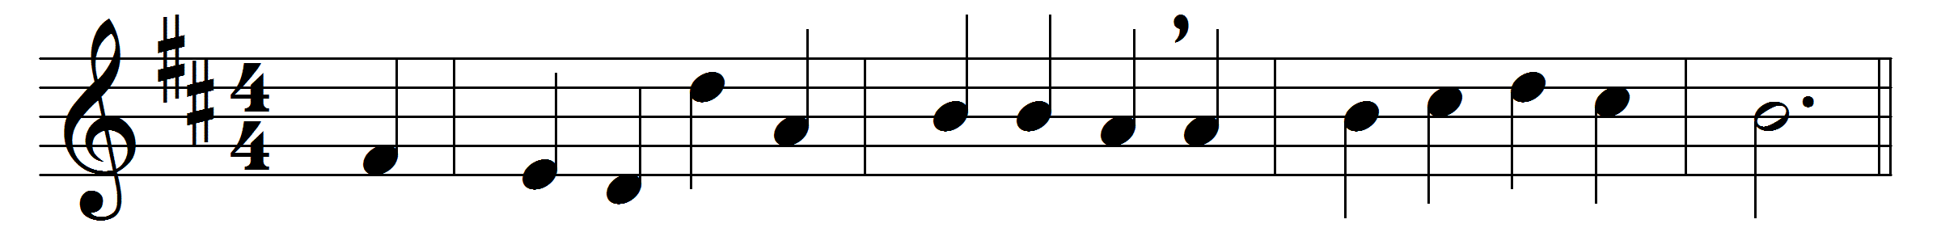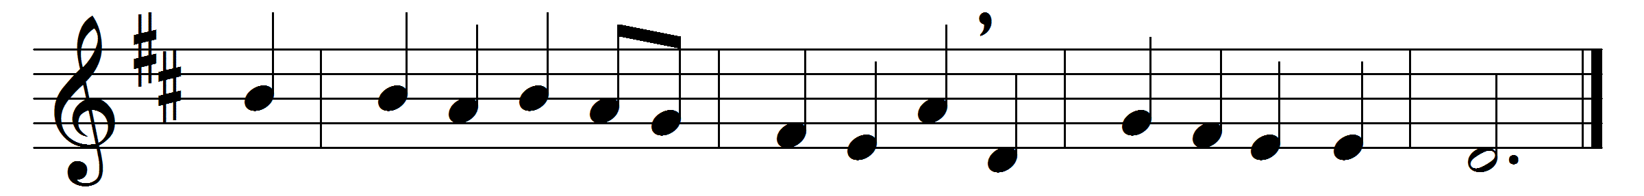

Jesu, our hope, our heart’s desire,
thy work of grace we sing;
Redeemer of the world art thou,
its Maker and its King.

How vast the mercy and the love
which laid our sins on thee,
and led thee to a cruel death,
to set thy people free!

But now the bonds of death are burst,
the ransom has been paid;
and thou art on thy Father’s throne,
in glorious robes arrayed.

O may thy mighty love prevail
our sinful souls to spare;
O may we stand around thy throne,
and see thy glory there.

Jesu, our only joy be thou,
as thou our prize wilt be;
in thee be all our glory now
and through eternity.

All praise to thee who art gone up
triumphantly to heaven;
all praise to God the Father’s name,
and Holy Ghost be given.

Words: Latin, translated by J. Chandler (1806-1876)
Music: R. Redhead (1820-1901)

