Good Christian men, rejoice and sing AMNS 85
Melody: Gelobt sei Gott 8 8 8. with Alleluias

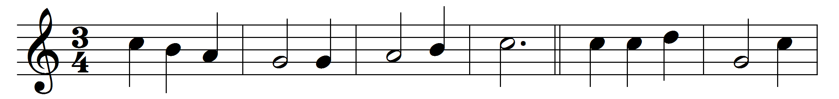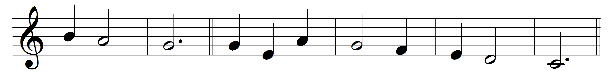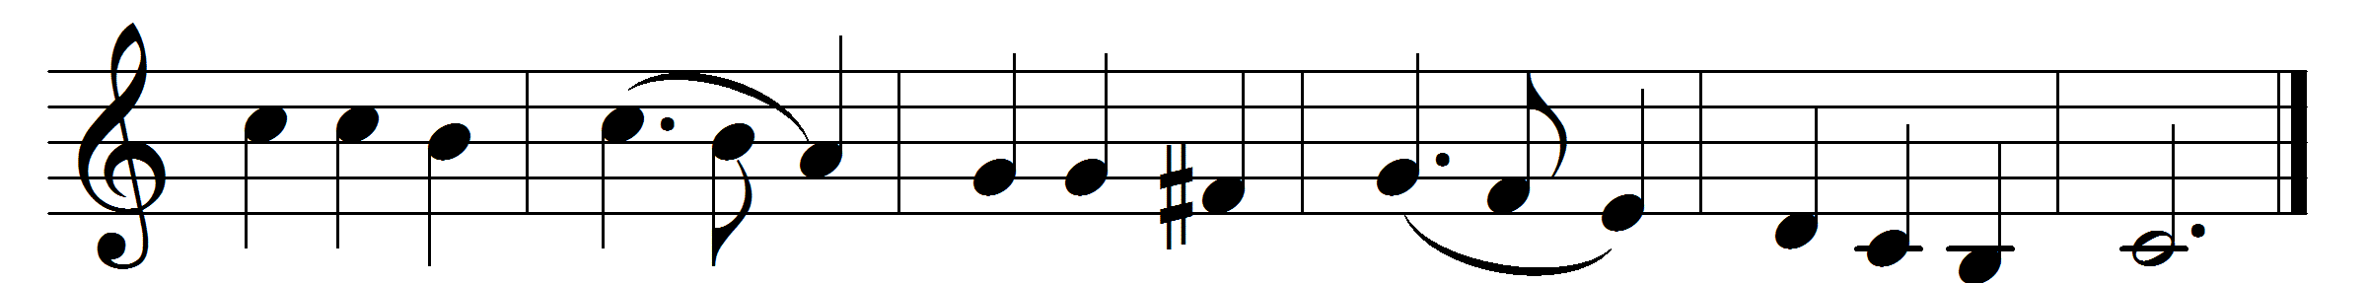

Good Christian men, rejoice and sing.
Now is the triumph of our King.
To all the world glad news we bring:
Alleluia.

The Lord of Life is risen for ay:
bring flowers of song to strew his way;
let all mankind rejoice and say
Alleluia.

Praise we in songs of victory
that Love, that Life, which cannot die,
and sing with hearts uplifted high
Alleluia.

Thy name we bless, O risen Lord,
and sing to-day with one accord
the life laid down, the life restored:
Alleluia.

Words: Cyril A. Alington (1872-1955)
Music: Melody from Melchior Vulpius (Gesangbuch, 1609)

