The Lord is risen indeed AMNS 84 Melody: St. Michael S.M.
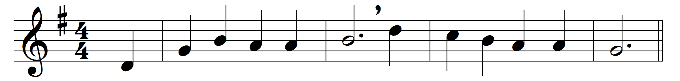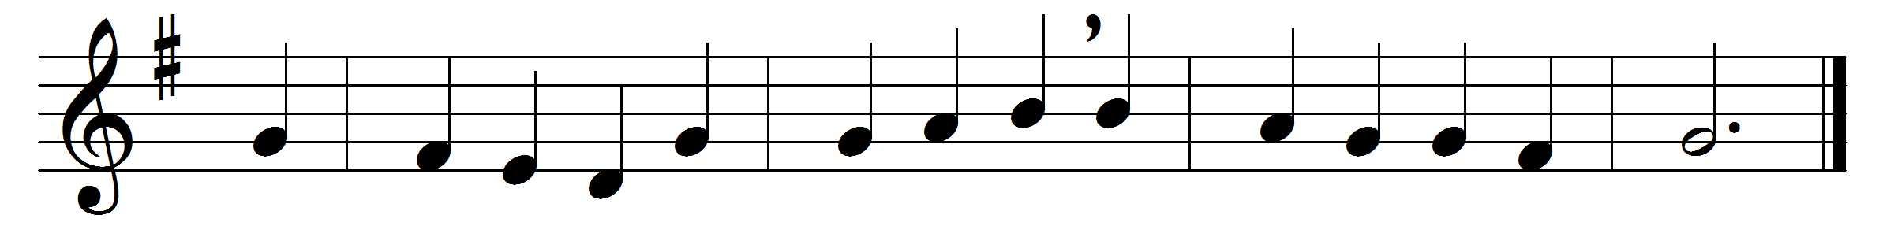

The Lord is risen indeed:
now is his work performed;
now is the mighty captive freed,
and death’s strong castle stormed.

The Lord is risen indeed:
then hell has lost his prey;
with him is risen the ransomed seed
to reign in endless day.

The Lord is risen indeed:
he lives, to die no more;
he lives, the sinner’s cause to plead,
whose curse and shame he bore.

The Lord is risen indeed:
attending angels, hear!
up to the courts of heaven with speed
the joyful tidings bear.

Then take your golden lyres,
and strike each cheerful chord;
join, all ye bright celestial choirs,
to sing our risen Lord.

Words: Thomas Kelly (1769-1855)
Music: Adapted from Anglo-Genevan Psalms, 1561

