Love’s redeeming work is done AMNS 83 Melody: Savannah 7 7. 7 7.

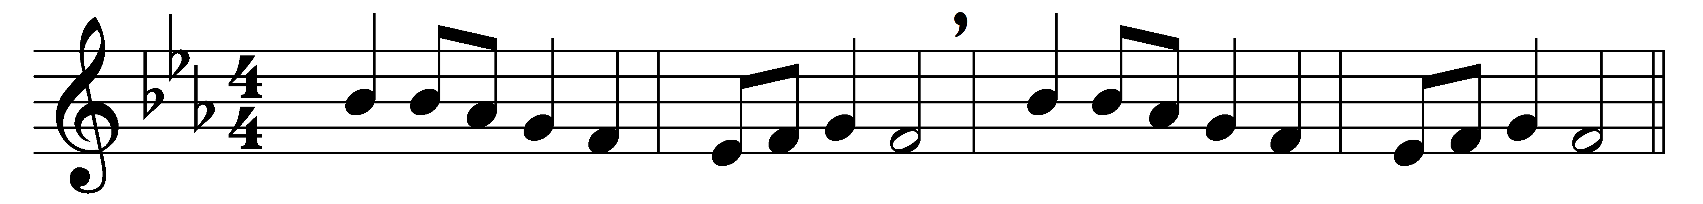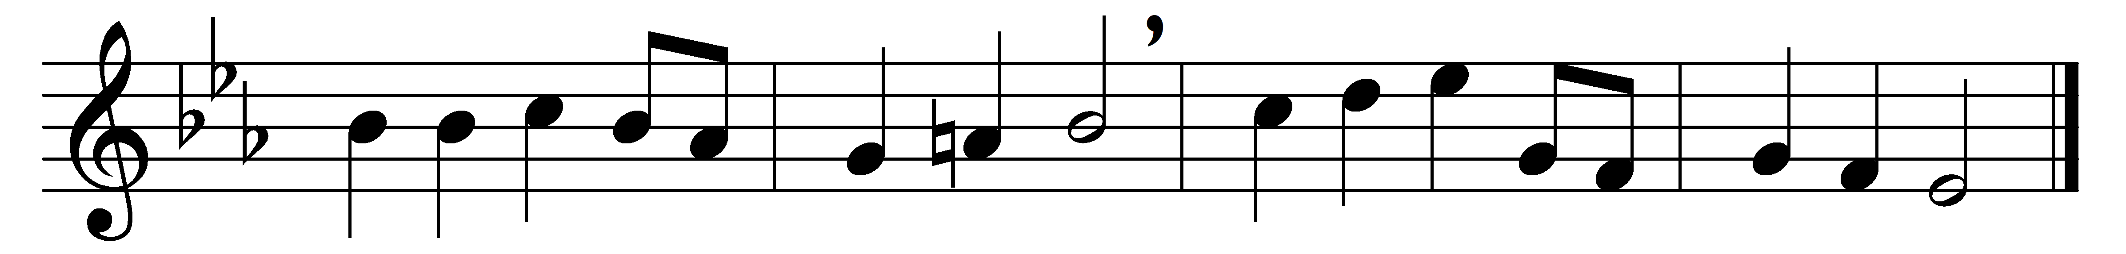

Love’s redeeming work is done;
fought the fight, the battle won:
lo, our Sun’s eclipse is o’er,
lo, he sets in blood no more.

Vain the stone, the watch, the seal;
Christ has burst the gates of hell;
death in vain forbids his rise;
Christ has opened Paradise.
Lives again our glorious King;
where, O death, is now thy sting?
dying once, he all doth save;
where thy victory, O grave?
Soar we now where Christ has led,
following our exalted Head;
made like him, like him we rise;
ours the cross, the grave, the skies.
Hail the Lord of earth and heaven!
praise to thee by both be given:
thee we greet triumphant now;
hail, the Resurrection thou!

Words: Charles Wesley (1707-1788)
Music: John Wesley’s Foundery Collection, 1742

