Jesus lives! thy terrors now AMNS 82 Melody: St. Albinus 7 8. 7 8. with Alleluia
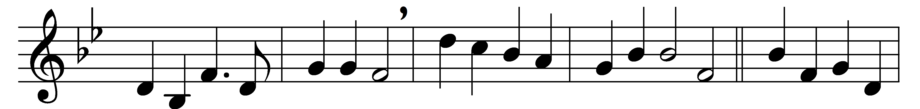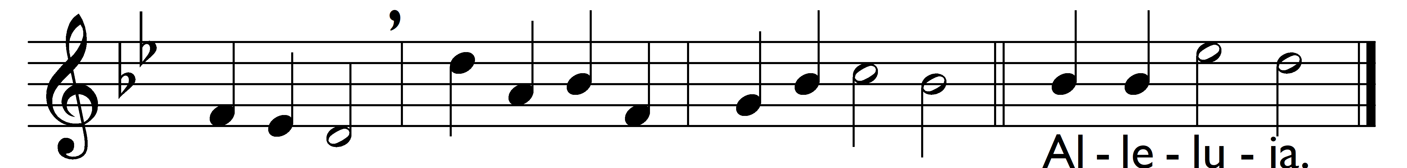

Jesus lives! thy terrors now
can no more, O death, appal us;
Jesus lives! by this we know
thou, O grave, canst not enthral us.
Alleluia.
Jesus lives! henceforth is death
but the gate of life immortal:
this shall calm our trembling breath,
when we pass its gloomy portal.
Alleluia.
Jesus lives! for us he died;
then, alone to Jesus living,
pure in heart may we abide,
glory to our Saviour giving.
Alleluia.
Jesus lives! our hearts know well
naught from us his love shall sever;
life nor death nor powers of hell
tear us from his keeping ever.
Alleluia.
Jesus lives! to him the throne
over all the world is given:
may we go where he is gone,
rest and reign with him in heaven.
Alleluia.

Words: Christian Fürchtegott Gellert (1715-1769), translated by Frances Elizabeth Cox (1812-1897)
Music: Henry John Gauntlett (1805-1876)

