O sons and daughters, let us sing! AMNS 74 Melody: O filii et filiae 8 8 8. with Alleluia
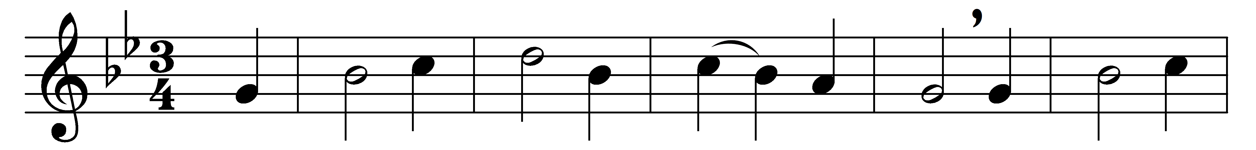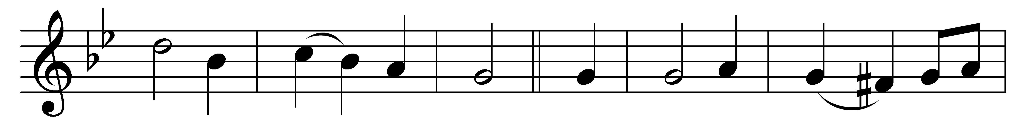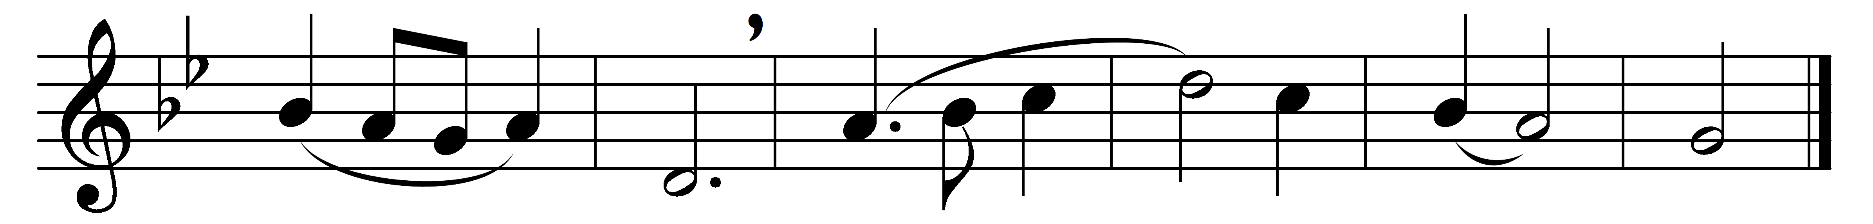

O sons and daughters, let us sing!
The King of heaven, the glorious King,
o’er death to-day rose triumphing.
Alleluia.

That Easter morn, at break of day,
the faithful women went their way
to seek the tomb where Jesus lay.
Alleluia.

An angel clad in white they see,
who sat, and spake unto the three,
‘Your Lord doth go to Galilee.’
Alleluia.

That night the apostles met in fear;
amidst them came their Lord most dear,
and said, ‘My peace be on all here.’
Alleluia.

When Thomas first the tidings heard,
how they had seen the risen Lord,
he doubted the disciples’ word.
Alleluia.

‘My piercèd side, O Thomas, see;
my hands, my feet I show to thee;
not faithless, but believing be.’
Alleluia.

No longer Thomas then denied;
he saw the feet, the hands, the side;
‘Thou art my Lord and God,’ he cried.
Alleluia.

How blest are they who have not seen,
and yet whose faith hath constant been,
for they eternal life shall win.
Alleluia.

On this most holy day of days,
to God your hearts and voices raise
in laud and jubilee and praise,
Alleluia.

Words: Jean Tisserand (d. 1419), translated by John Mason Neale (1818-1866)
Music: French melody (17th century)

