Ye choirs of new Jerusalem AMNS 73 Melody: St. Fulbert C.M.
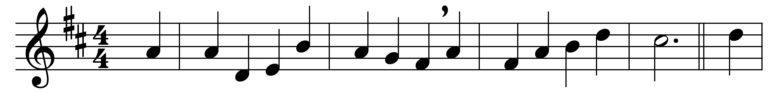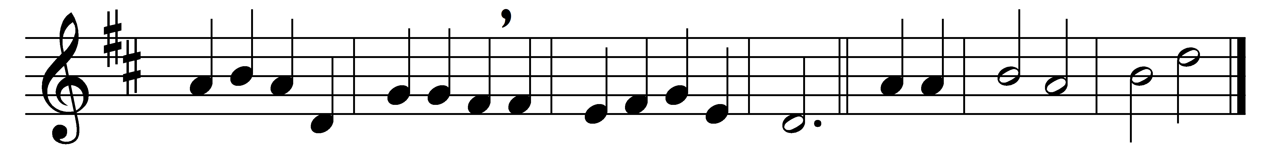

Ye choirs of new Jerusalem,
your sweetest notes employ,
the paschal victory to hymn
in strains of holy joy.

For Judah’s Lion bursts his chains,
crushing the serpent’s head;
and cries aloud through death’s domains
to wake the imprisoned dead.

Devouring depths of hell their prey
at his command restore;
his ransomed hosts pursue their way
where Jesus goes before.

Triumphant in his glory now
to him all power is given;
to him in one communion bow
all saints in earth and heaven.

While we his soldiers praise our King,
his mercy we implore,
within his palace bright to bring
and keep us evermore.

All glory to the Father be,
all glory to the Son,
all glory, Holy Ghost, to thee,
while endless ages run. Alleluia. Amen.

Words: St. Fulbert of Chartres (d. 1028), translated by Robert Campbell (1814-1868)
Music: Henry John Gauntlett (1805-1876)

