O dearest Lord, thy sacred head AMNS 71 Melody: Albano C. M.
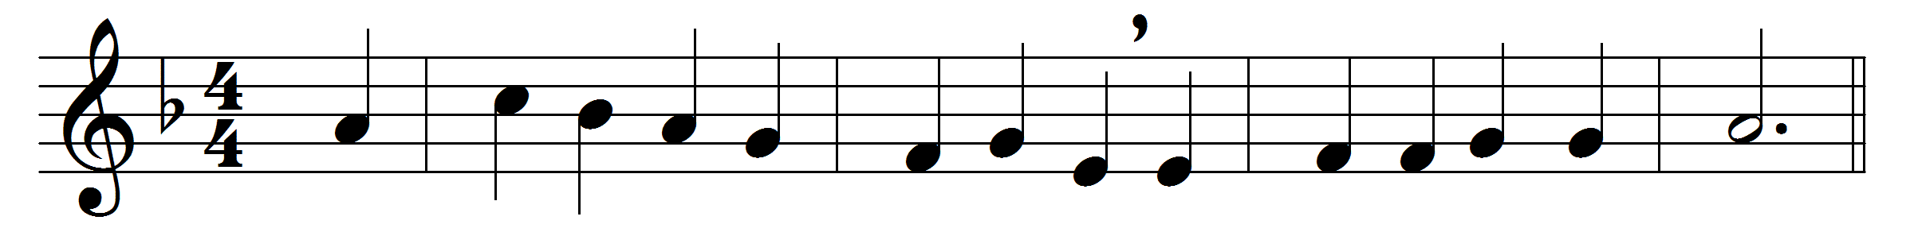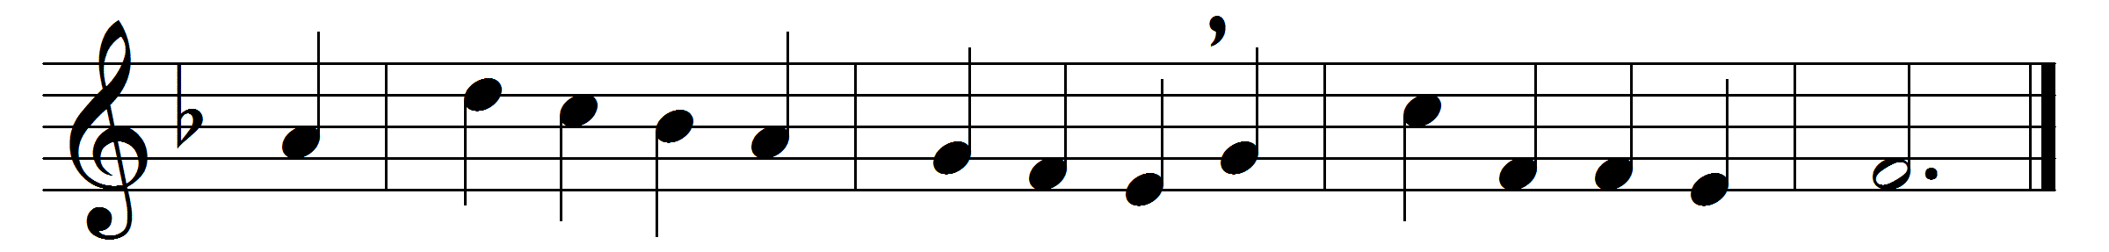

O dearest Lord, thy sacred head
with thorns was pierced for me;
O pour thy blessing on my head
that I may think for thee.

O dearest Lord, thy sacred hands
with nails were pierced for me;
O shed thy blessing on my hands
that they may work for thee.

O dearest Lord, thy sacred feet
with nails were pierced for me;
O pour thy blessing on my feet
that they may follow thee.

O dearest Lord, thy sacred heart
with spear was pierced for me;
O pour thy Spirit in my heart
that I may live for thee.

Words: Henry Ernest Hardy (Father Andrew) (1869-1946)
Music: Vincent Novello (1781-1861)

