Before the ending of the day AMNS 6 Melody: Te Lucis L.M.
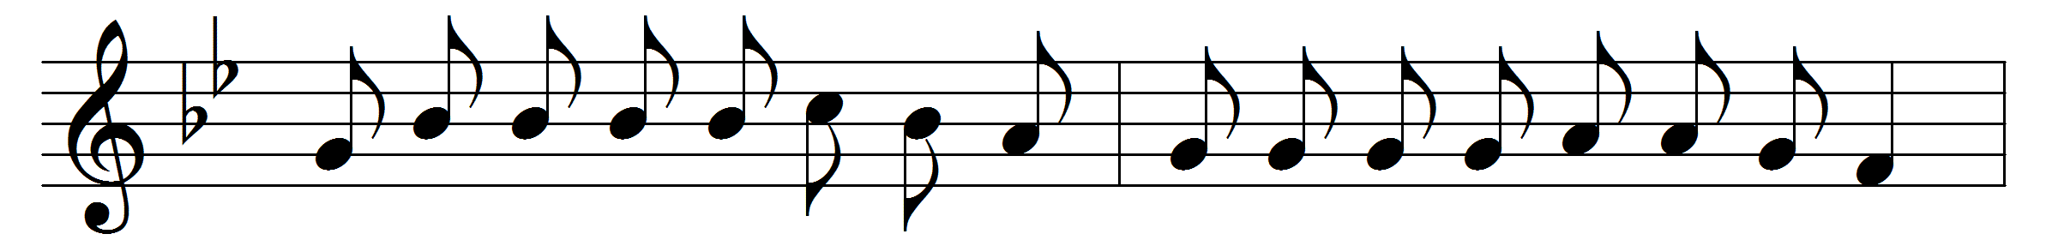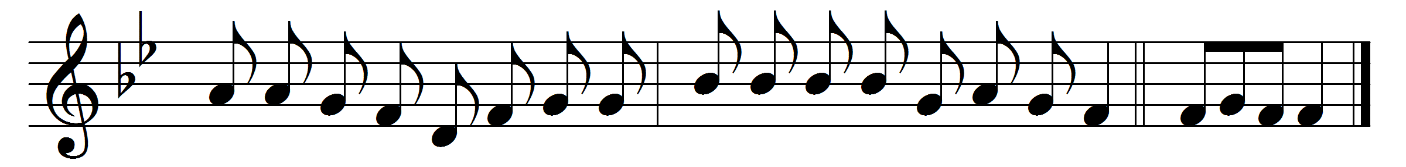

Before the ending of the day,
Creator of the world, we pray,
that with thy wonted favour thou
wouldst be our guard and keeper now.

From all ill dreams defend our eyes,
from nightly fears and fantasies;
tread under foot our ghostly foe,
that no pollution we may know.

O Father, that we ask be done,
through Jesus Christ thine only Son,
who, with the Holy Ghost and thee,
doth live and reign eternally. Amen.

Words: Latin, translated by John Mason Neale (1818-1866)
Music: Mode viii

