O sacred head, surrounded AMNS 68 Melody: Passion Chorale 7 6. 7 6. D.

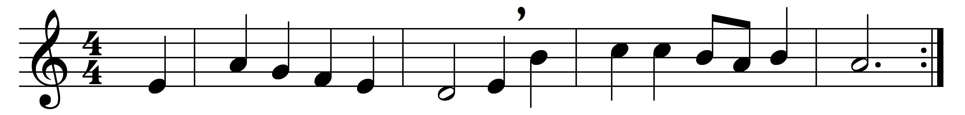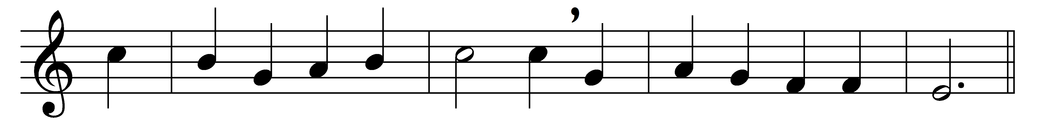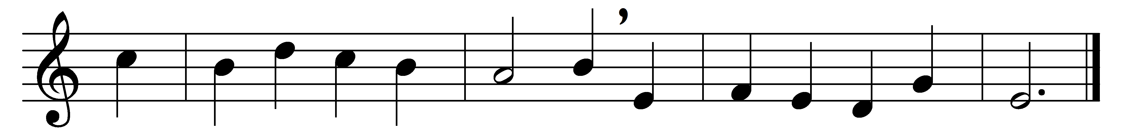

O sacred head, surrounded
by crown of piercing thorn!
O bleeding head, so wounded,
so shamed and put to scorn!
Death’s pallid hue comes o’er thee,
the glow of life decays;
yet angel-hosts adore thee,
and tremble as they gaze.

Thy comeliness and vigour
is withered up and gone,
and in thy wasted figure
I see death drawing on.
O agony and dying!
O love to sinners free!
Jesu, all grace supplying,
turn thou thy face on me.

In this thy bitter passion,
good Shepherd, think of me
with thy most sweet compassion,
unworthy though I be:
beneath thy Cross abiding
for ever would I rest,
in thy dear love confiding,
and with thy presence blest.

Words: Paul Gerhardt (1607-1676), translated by Henry Williams Baker (1821-1877)
Music: Melody by Hans Leo Hassler (1564-1612), harmony from Johann Sebastian Bach (1685-1750)

