When I survey the wondrous Cross AMNS 67 Melody: Rockingham L.M.
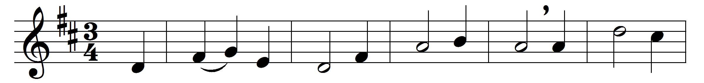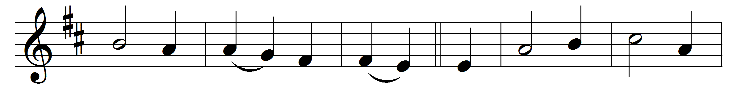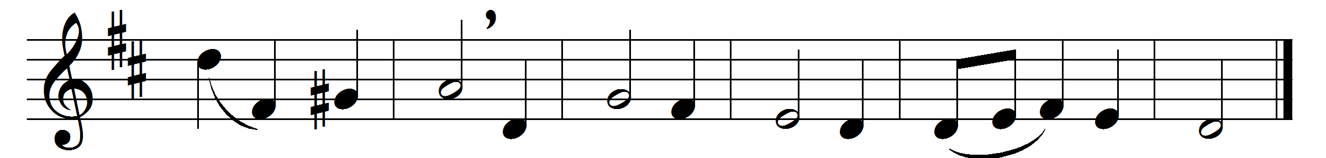

When I survey the wondrous Cross
on which the Prince of Glory died,
my richest gain I count but loss,
and pour contempt on all my pride.

Forbid it, Lord, that I should boast
save in the Cross of Christ my God;
all the vain things that charm me most,
I sacrifice them to his blood.

See from his head, his hands, his feet,
sorrow and love flow mingling down;
did e’er such love and sorrow meet,
or thorns compose so rich a crown?

Were the whole realm of nature mine,
that were an offering far too small;
love so amazing, so divine,
demands my soul, my life, my all.

Words: Isaac Watts (1674-1748)
Music: Adapted by Edward Miller (1735-1807)

