Glory be to Jesus AMNS 66 Melody: Caswall 6 5. 6 5.
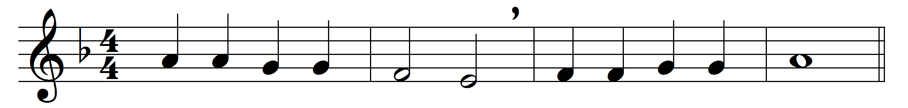

Glory be to Jesus,
who, in bitter pains,
poured for me the life-blood
from his sacred veins.

Grace and life eternal
in that blood I find;
blest be his compassion
infinitely kind.

Blest through endless ages
be the precious stream,
which from endless torments
did the world redeem.

Abel’s blood for vengeance
pleaded to the skies;
but the blood of Jesus
for our pardon cries.

Oft as it is sprinkled
on our guilty hearts,
Satan in confusion
terror-struck departs;

oft as earth exulting
wafts its praise on high,
angel-hosts rejoicing
make their glad reply.

Lift ye then your voices;
swell the mighty flood;
louder still and louder
praise the precious blood.

Words: Translated from Italian by Edward Caswall (1814-1878)
Music: Friedrich Filitz (1804-1876)

