Ride on, ride on in majesty! AMNS 61 Melody: St. Drostane L.M.
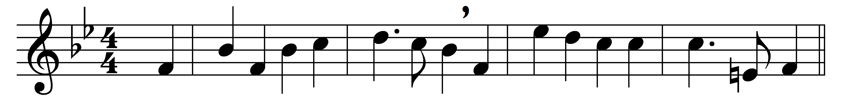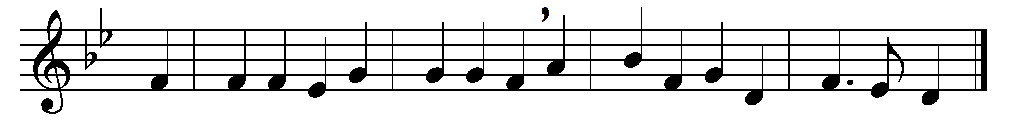

Ride on, ride on in majesty!
Hark, all the tribes hosanna cry.
O Saviour meek, pursue thy road
with palms and scattered garments strowed.

Ride on, ride on in majesty!
In lowly pomp ride on to die:
O Christ, thy triumphs now begin
o’er captive death and conquered sin.

Ride on, ride on in majesty!
The wingèd squadrons of the sky
look down with sad and wondering eyes
to see the approaching sacrifice.

Ride on, ride on in majesty!
The last and fiercest strife is nigh:
the Father on his sapphire throne
awaits his own anointed Son.

Ride on, ride on in majesty!
In lowly pomp ride on to die;
bow thy meek head to mortal pain,
then take, O God, thy power, and reign.

Words: Henry Hart Milman (1791-1868)
Music: John Bacchus Dykes (1823-1876)

