O Trinity, most blessed light AMNS 5 Melody: Westminster L.M.
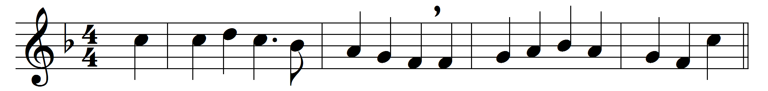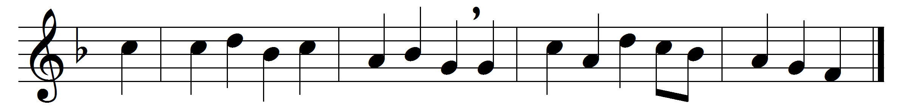

O Trinity, most blessèd light,
O Unity of sovereign might,
as now the fiery sun departs,
shed thou thy beams within our hearts.
To thee our morning song of praise,
to thee our evening prayer we raise;
thee may our souls for evermore
in lowly reverence adore.
All praise to God the Father be,
all praise, eternal Son, to thee,
whom with the Spirit we adore,
for ever and for evermore.

Words: St. Ambrose (c. 340-397), translated by John Mason Neale (1818-1866)
Music: adapted from Benjamin Cooke (1734-1793)

