The royal banners forward go AMNS 58 Melody: Vexilla Regis L.M.
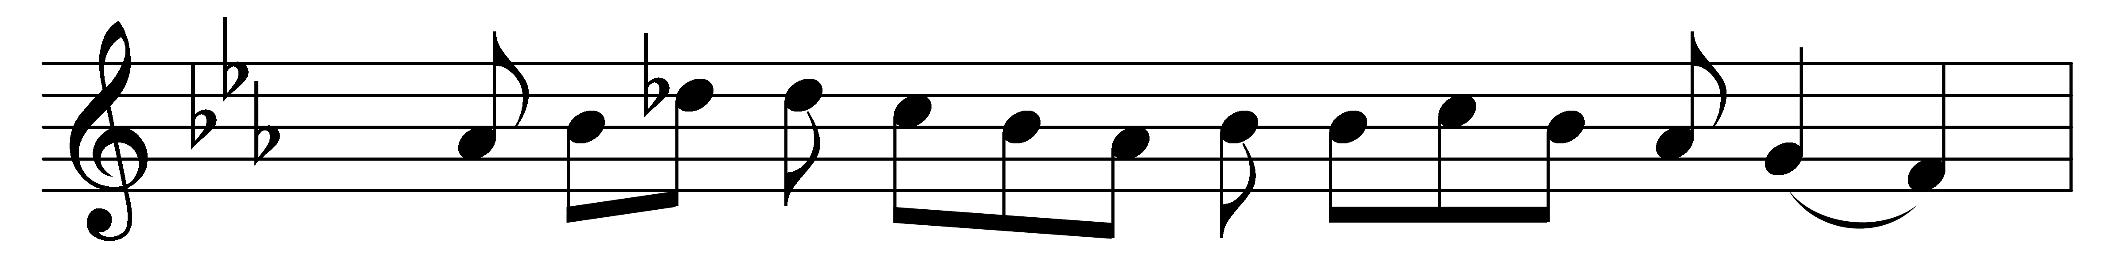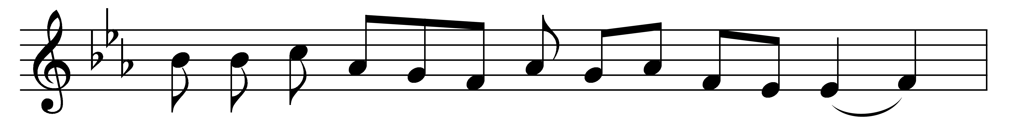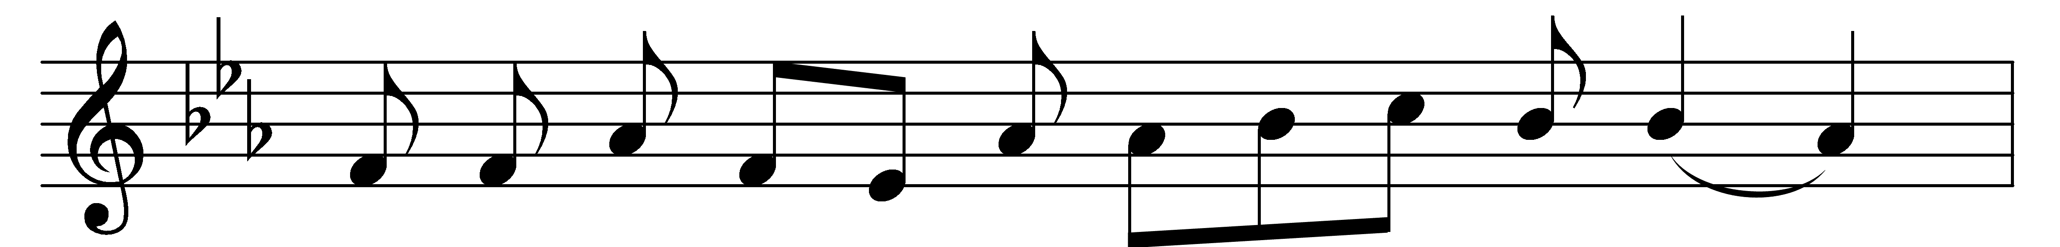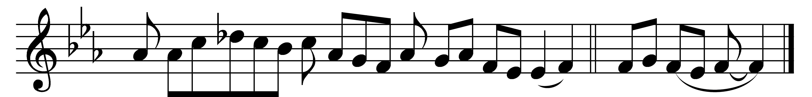

The royal banners forward go,
the Cross shines forth in mystic glow;
where he in flesh, our flesh who made,
our sentence bore, our ransom paid.

There whilst he hung, his sacred side
by soldier’s spear was opened wide,
to cleanse us in the precious flood
of water mingled with his blood.

Fulfilled is now what David told
in true prophetic song of old,
how God the heathen’s King should be;
for God is reigning from the Tree.

O Tree of glory, Tree most fair,
ordained those holy limbs to bear,
how bright in purple robe it stood,
the purple of a Saviour’s blood!

Upon its arms, like balance true,
he weighed the price for sinners due,
the price which none but he could pay,
and spoiled the spoiler of his prey.

To thee, eternal Three in One,
let homage meet by all be done:
as by the Cross thou dost restore,
so rule and guide us evermore. Amen.

Words: Venantius Fortunatus (c. 530-c. 600), translated by John Mason Neale (1818-1866)
Music: Mode i

