Forty days and forty nights AMNS 56 Melody: Aus der Tiefe (Heinlein) 7 7. 7 7.
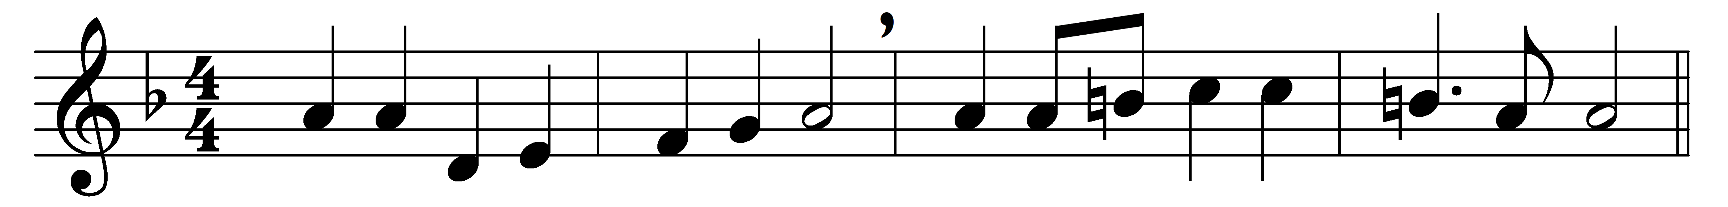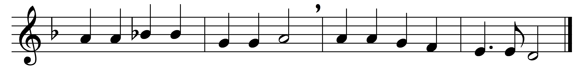

Forty days and forty nights
thou wast fasting in the wild;
forty days and forty nights
tempted, and yet undefiled:

sunbeams scorching all the day;
chilly dew-drops nightly shed;
prowling beasts about thy way;
stones thy pillow, earth thy bed.

Shall not we thy sorrows share,
and from earthly joys abstain,
fasting with unceasing prayer,
glad with thee to suffer pain?

And if Satan, vexing sore,
flesh or spirit should assail,
thou, his vanquisher before,
grant we may not faint nor fail.

So shall we have peace divine;
holier gladness ours shall be;
round us too shall angels shine,
such as ministered to thee.

Keep, O keep us, Saviour dear,
ever constant by thy side;
that with thee we may appear
at the eternal Eastertide.

Words: George Hunt Smyttan (1822-1870) and Francis Pott (1832-1909)
Music: Melody from Nürnbergisches Gesangbuch, 1676

