Thou whom shepherds worshipped, hearing AMNS 54 Melody: Quem pastores 8 8 8. 7.
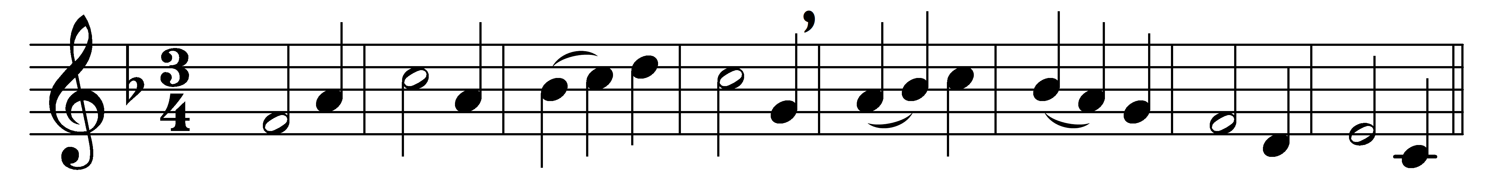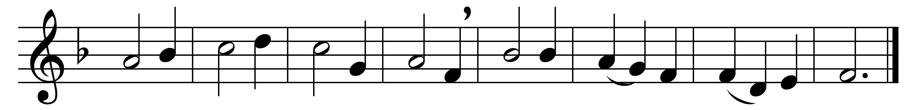

Thou whom shepherds worshipped, hearing
angels tell their tidings cheering,
‘Sirs, away with doubt and fearing!
Christ the King is born for all;’

thou to whom came wise men faring,
gold and myrrh and incense bearing,
heartfelt homage thus declaring
to the King that’s born for all:

bending low in adoration
thee we greet, for our salvation
given by wondrous incarnation,
King of Glory born for all.

Words: Latin, translated by Charles Stanley Phillips (1883-1949)
Music: German medieval melody

