Were you there when they crucified my Lord? AMNS 523
Melody: Were you there? Irregular metre
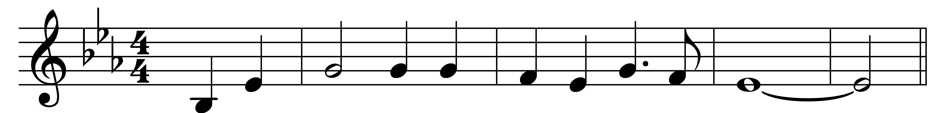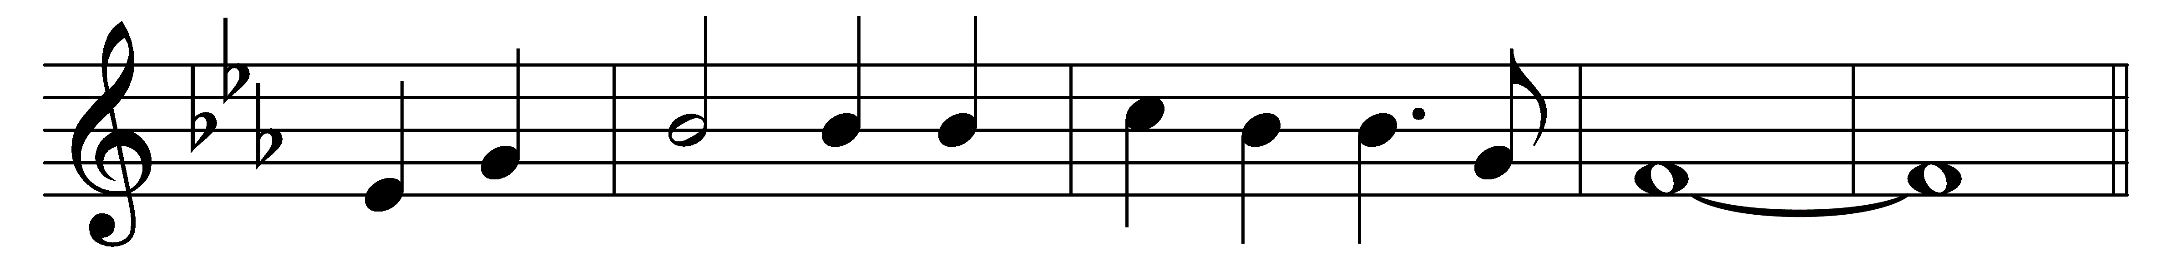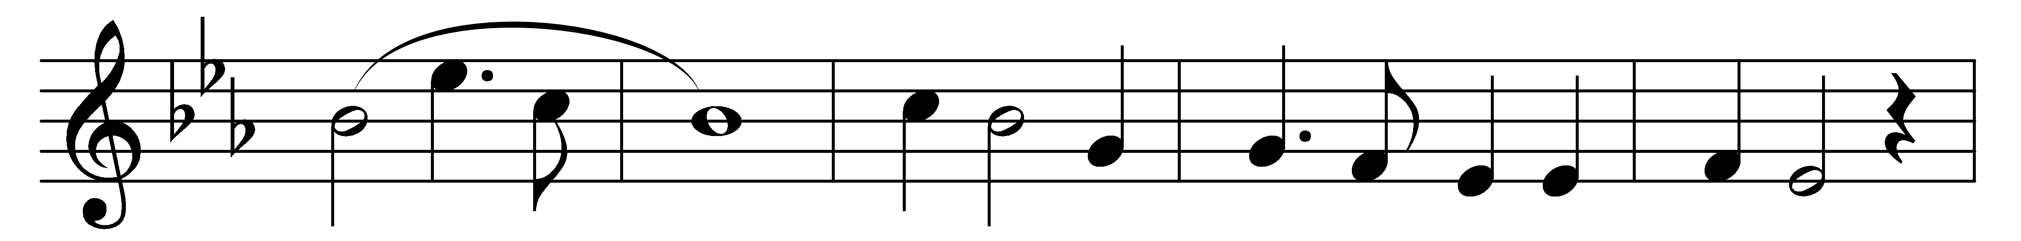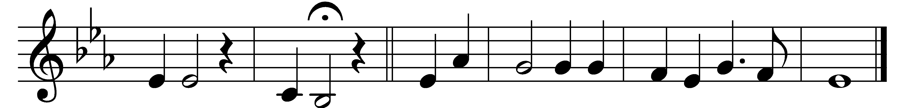

Were you there when they crucified my Lord?
Were you there when they crucified my Lord?
Oh, sometimes it causes me to tremble, tremble, tremble;
were you there when they crucified my Lord?

Were you there when they nailed him to the tree?
Were you there when they nailed him to the tree?
Oh, sometimes it causes me to tremble, tremble, tremble;
were you there when they nailed him to the tree?

Were you there when they laid him in the tomb?
Were you there when they laid him in the tomb?
Oh, sometimes it causes me to tremble, tremble, tremble;
were you there when they laid him in the tomb?

Words and music: American folk hymn

