As with gladness men of old AMNS 51 Melody: Dix 7 7. 7 7. 7 7.
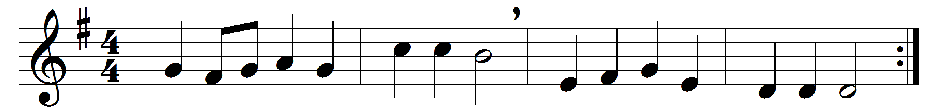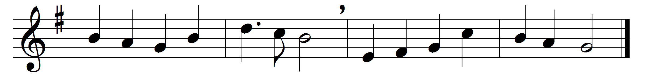

As with gladness men of old
did the guiding star behold,
as with joy they hailed its light,
leading onward, beaming bright;
so, most gracious Lord, may we
evermore be led to thee.
As with joyful steps they sped,
Saviour, to thy lowly bed,
there to bend the knee before
thee whom heaven and earth adore;
so may we with willing feet
ever seek thy mercy-seat.
As they offered gifts most rare
at thy cradle rude and bare,
so may we with holy joy,
pure and free from sin’s alloy,
all our costliest treasures bring,
Christ, to thee our heavenly King.

Holy Jesus, every day
keep us in the narrow way,
and, when earthly things are past,
bring our ransomed souls at last
where they need no star to guide,
where no clouds thy glory hide.
In the heavenly country bright
need they no created light;
thou its light, its joy, its crown,
thou its sun which goes not down;
there for ever may we sing
alleluias to our King.

Words: William Chatterton Dix (1837-1898)
Music: Adapted from Conrad Kocher (1786-1872) by William Henry Monk (1823-1889)

