Nature with open volume stands AMNS 497 Melody: Rivaulx L.M.
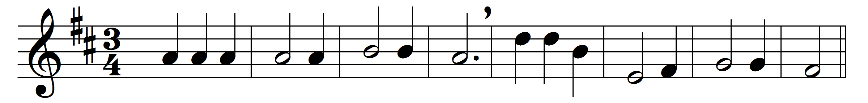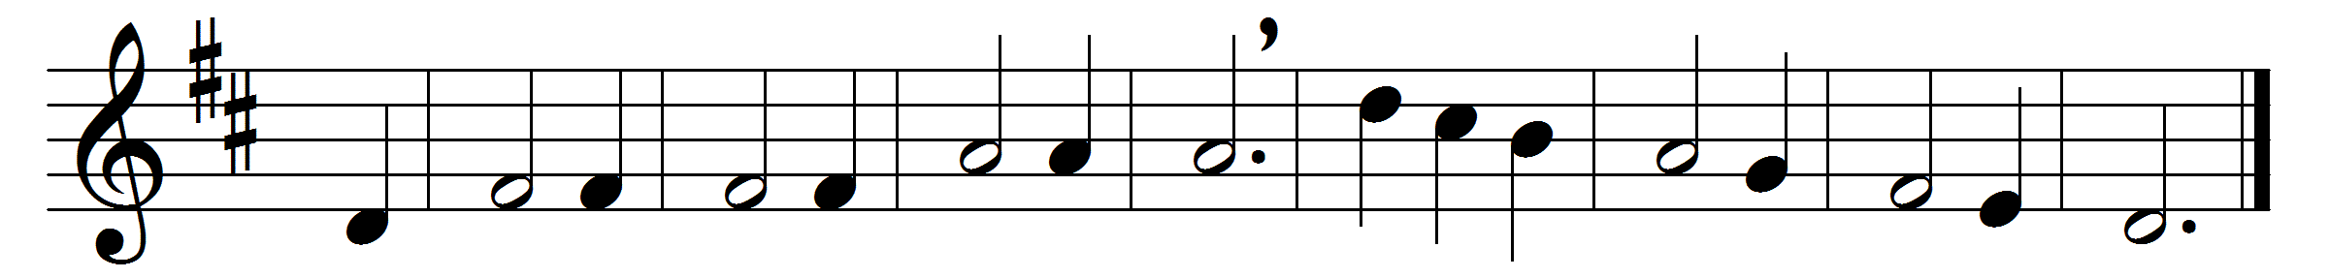
Nature with open volume stands
to spread her maker’s praise abroad,
and every labour of his hands
shows something worthy of our God.

But in the grace that rescued man
his brightest form of glory shines;
here on the Cross ’tis fairest drawn
in precious blood and crimson lines.

Here his whole name appears complete;
nor wit can guess, nor reason prove
which of the letters best is writ,
the power, the wisdom, or the love.

O the sweet wonders of that Cross
where God the Saviour loved and died;
her noblest life my spirit draws
from his dear wounds and bleeding side.

I would for ever speak his name
in sounds to mortal ears unknown,
with angels join to praise the Lamb,
and worship at his Father’s throne.

Words: Isaac Watts (1674-1748)
Music: John Bacchus Dykes (1823-1876)

