Lord of all, to whom alone AMNS 492 Melody: Huddersfield 7. 7. 7. 5.
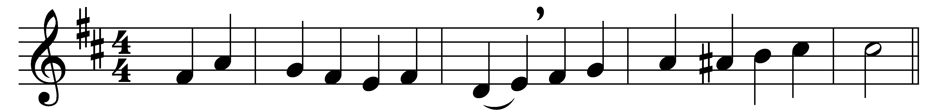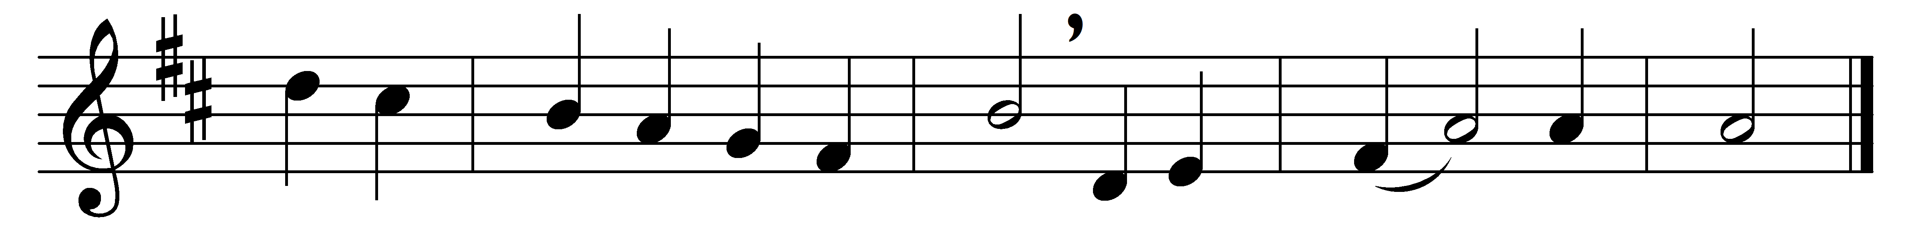

Lord of all, to whom alone
all our hearts’ desires are known,
when we stand before thy throne,
Jesu, hear and save.

Son of Man, before whose eyes
every secret open lies,
at thy great and last assize,
Jesu, hear and save.

Son of God, whose angel host
(thou hast said) rejoiceth most
o’er the sinner who was lost,
Jesu, hear and save.

Saviour, who didst not condemn
those who touched thy garments’ hem,
mercy show to us and them:
Jesu, hear and save.

Lord, the Way to sinners shown,
Lord, the Truth by sinners known,
Love Incarnate on the throne,
Jesu, hear and save.

Words: Cyril A. Alington (1872-1955)
Music: Walter Parratt (1841-1924)

