Lord Jesus Christ, be present now AMNS 491 Melody: Niagara L.M.
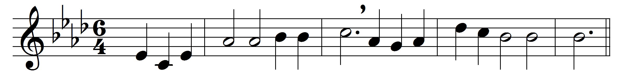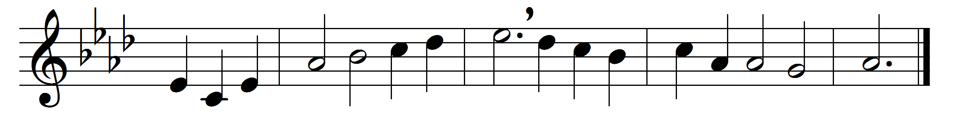

Lord Jesus Christ, be present now,
and let your Holy Spirit bow
all hearts in love and fear today
to hear the truth and keep your way.
Open our lips to sing your praise,
our hearts in true devotion raise,
strengthen our faith, increase our light,
that we may know your name aright.

Words: Anonymous, German, translated by Catherine Winkworth (1827-1878)
Music: Robert Jackson (1840-1914)

