Lord, I have made thy word my choice AMNS 490 Melody: Billing C.M.
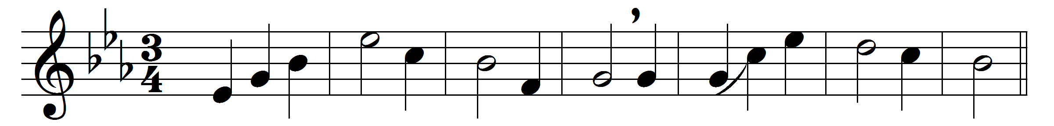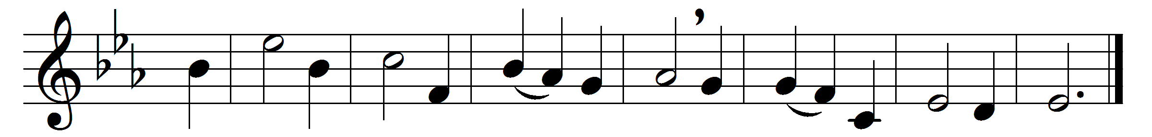

Lord, I have made thy word my choice,
my lasting heritage:
there shall my noblest powers rejoice,
my warmest thoughts engage.
I’ll read the histories of thy love,
and keep thy laws in sight,
while through thy promises I rove
with ever-fresh delight.
’Tis a broad land of wealth unknown,
where springs of life arise,
seeds of immortal bliss are sown,
and hidden glory lies.

Words: Isaac Watts (1674-1748)
Music: Richard Runciman Terry (1865-1938)

