Lift up your heads, you mighty gates AMNS 483 Melody: Truro L.M.
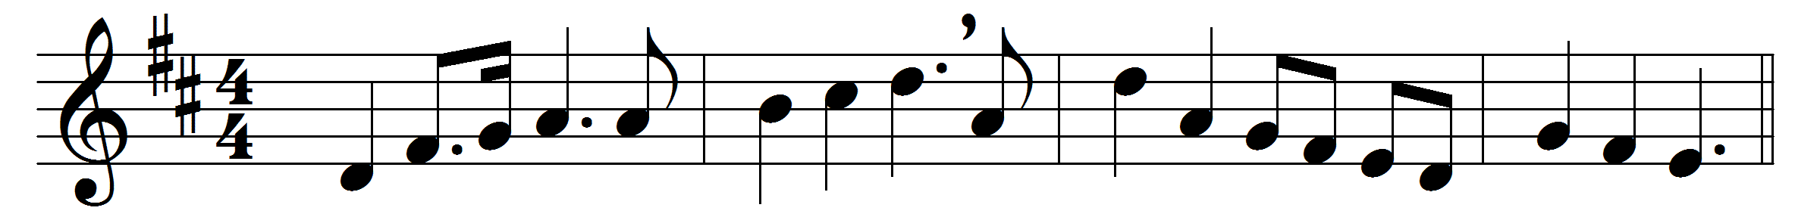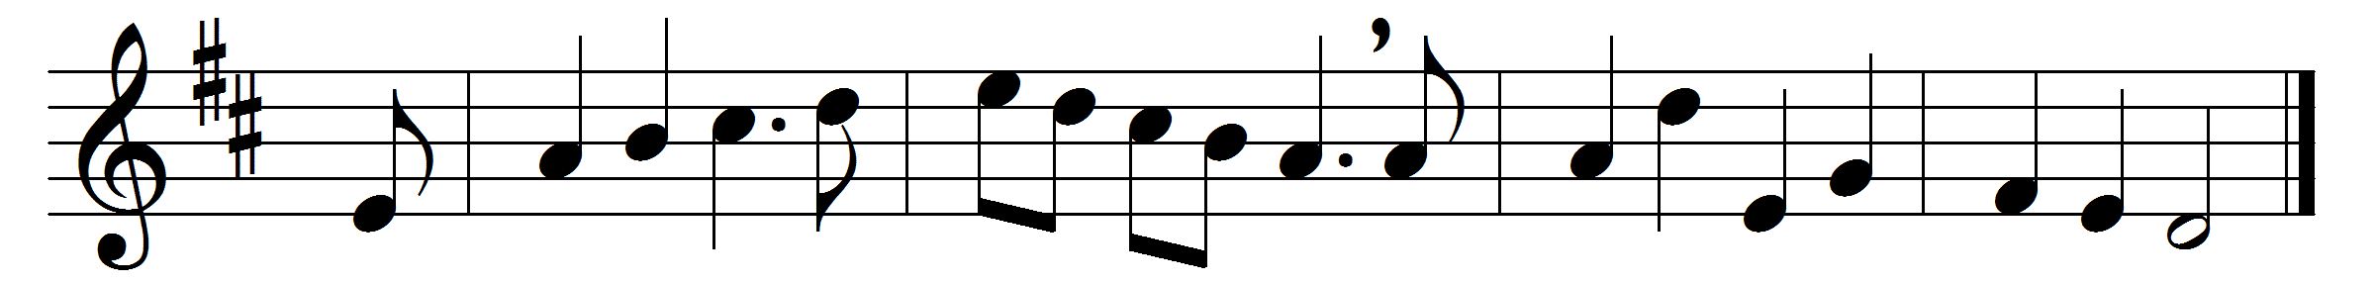

Lift up your heads, you mighty gates,
behold, the King of Glory waits,
the King of kings is drawing near,
the Saviour of the world is here.
O blest the land, the city blest
where Christ the ruler is confessed.
O happy hearts and happy homes
to whom this King in triumph comes.
Fling wide the portals of your heart,
make it a temple set apart
from earthly use for heaven’s employ,
adorned with prayer and love and joy.
Come, Saviour, come, with us abide;
our hearts to thee we open wide:
thy Holy Spirit guide us on,
until our glorious goal is won.

Words: Georg Weissel (1590-1635), translated by Catherine Winkworth (1827-1878)
Music: Melody from Thomas Williams’s Psalmodia Evangelica, 1789

