Let us break bread together on our knees AMNS 480 Melody: Let us break bread Irregular metre
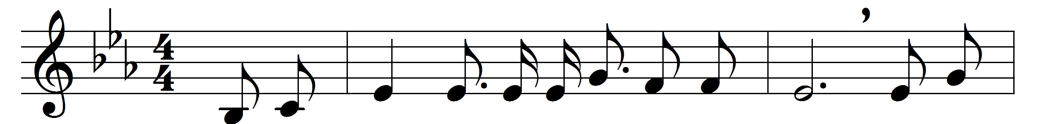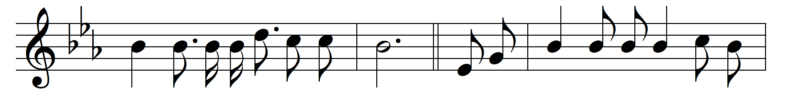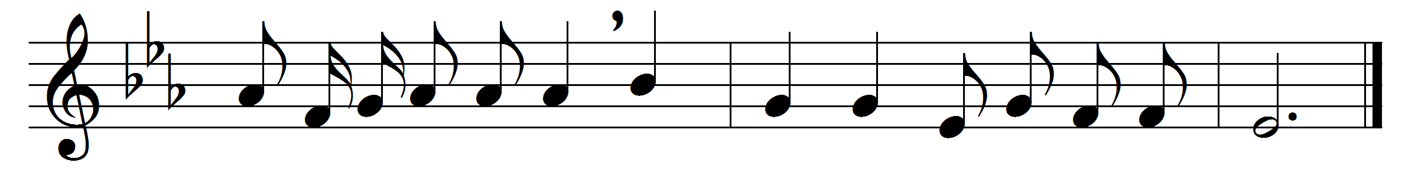

Let us break bread together on our knees;
let us break bread together on our knees:
Refrain:
when I fall on my knees
with my face to the rising sun,
O Lord, have mercy, if you please.
Let us drink wine together on our knees;
let us drink wine together on our knees:
Refrain

Let us praise God together on our knees;
let us praise God together on our knees:
Refrain

Words: Traditional American
Music: Traditional American

