Jesus, we thus obey AMNS 477 Melody: Windermere S.M.
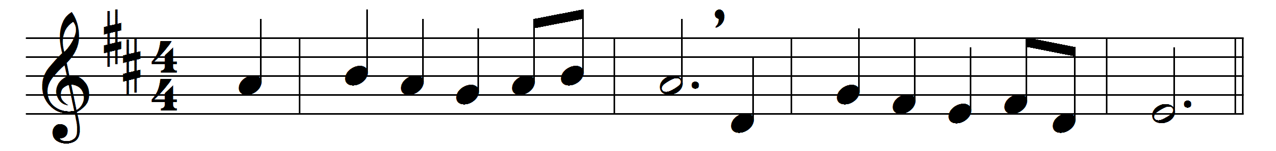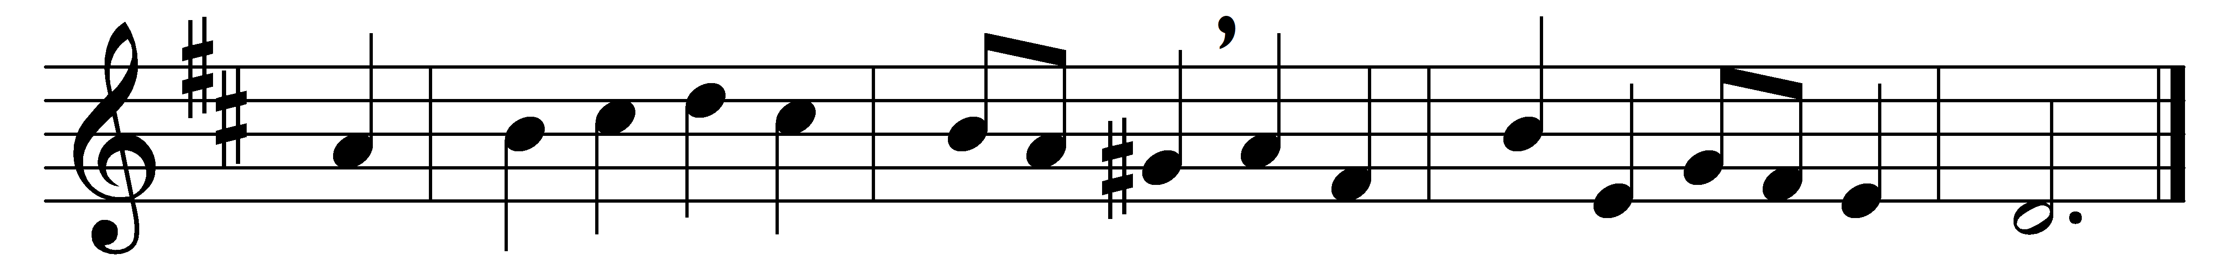

Jesus, we thus obey
thy last and kindest word;
here in thine own appointed way
we come to meet thee, Lord.
Our hearts we open wide
to make the Saviour room;
and lo, the Lamb, the Crucified,
the sinner’s friend, is come.
Thy presence makes the feast;
now let our spirits feel
the glory not to be expressed,
the joy unspeakable.
With high and heavenly bliss
thou dost our spirits cheer;
thy house of banqueting is this
and thou hast brought us here.
Now let our souls be fed
with manna from above,
and over us thy banner spread
of everlasting love.

Words: Charles Wesley (1707-1788)
Music: Arthur Somervell (1863-1937)

