How shall I sing that majesty AMNS 472 Melody: Soll’s sein D. C. M.
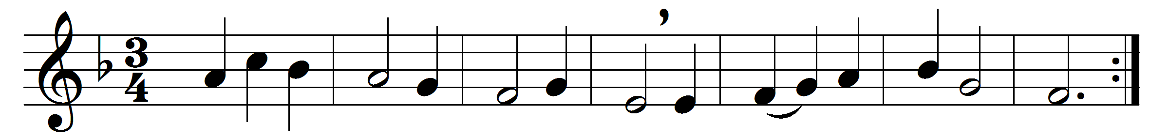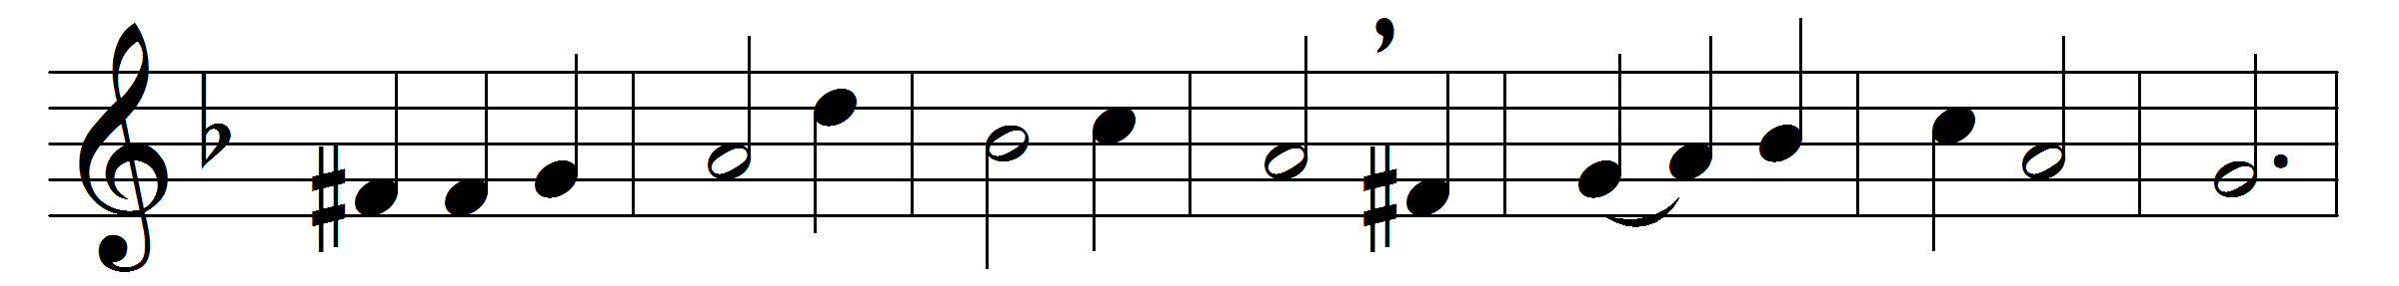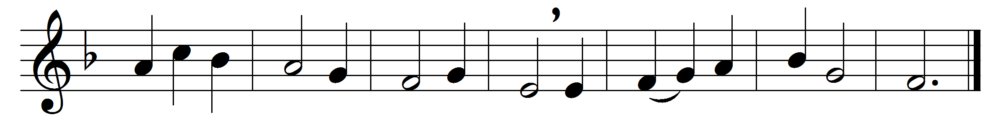

How shall I sing that majesty
which angels do admire?
let dust in dust and silence lie;
sing, sing, ye heavenly choir.
Thousands of thousands stand around
thy throne, O God most high;
ten thousand times ten thousand sound
thy praise; but who am I?

Thy brightness unto them appears,
whilst I thy footsteps trace;
a sound of God comes to my ears,
but they behold thy face.
They sing because thou art their Sun;
Lord, send a beam on me;
for where heaven is but once begun
there alleluias be.

How great a being, Lord, is thine,
which doth all beings keep!
Thy knowledge is the only line
to sound so vast a deep.
Thou art a sea without a shore,
a sun without a sphere;
thy time is now and evermore,
thy place is everywhere.

Words: John Mason (c. 1645-1694)
Music: Melody from David Gregor Corner’s Geistliche Nachtigal, 1649

