Give to our God immortal praise AMNS 460 Melody: Warrington L.M.
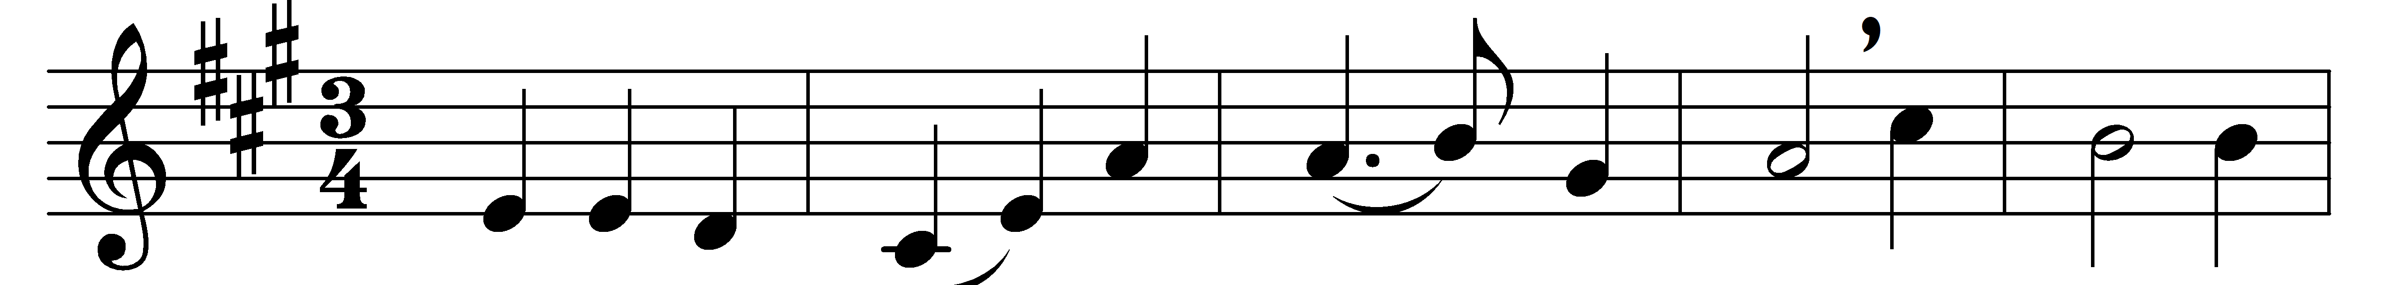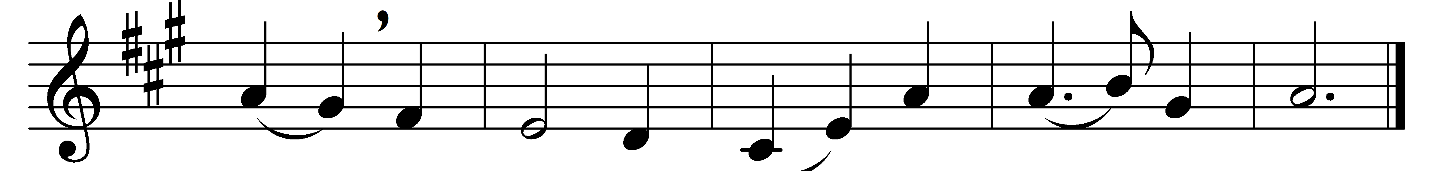

Give to our God immortal praise;
mercy and truth are all his ways:
wonders of grace to God belong,
repeat his mercies in your song.

Give to the Lord of lords renown,
the King of kings with glory crown:
his mercies ever shall endure
when lords and kings are known no more.

He sent his Son with power to save
from guilt and darkness and the grave:
wonders of grace to God belong,
repeat his mercies in your song.

Through this vain world he guides our feet,
and leads us to his heavenly seat:
his mercies ever shall endure
when this vain world shall be no more.

Words: Isaac Watts (1674-1748)
Music: Ralph Harrison (1748-1810)

