Give me joy in my heart, keep me praising AMNS 459 Melody: Sing Hosanna 10 8. 10 9. and refrain
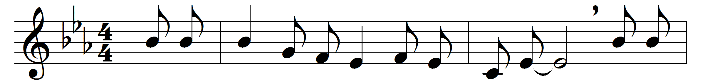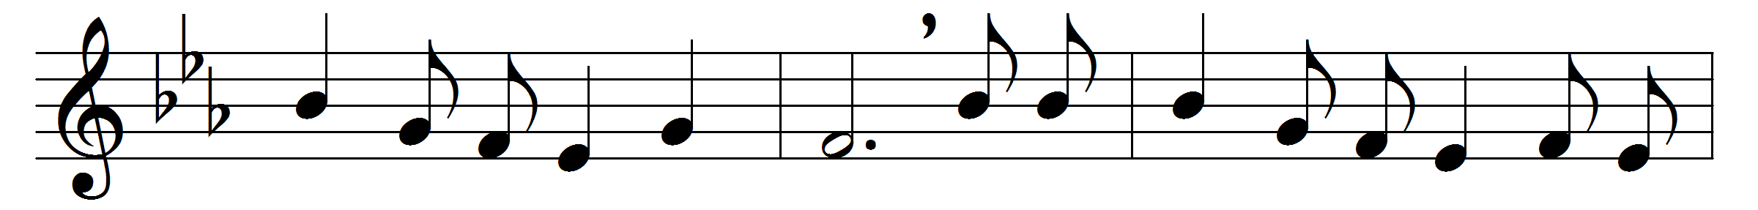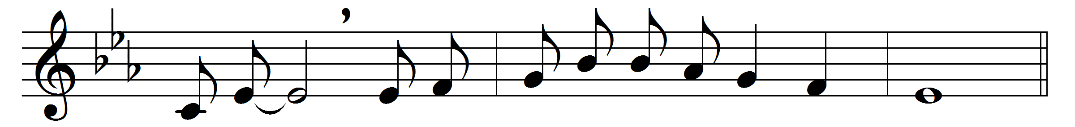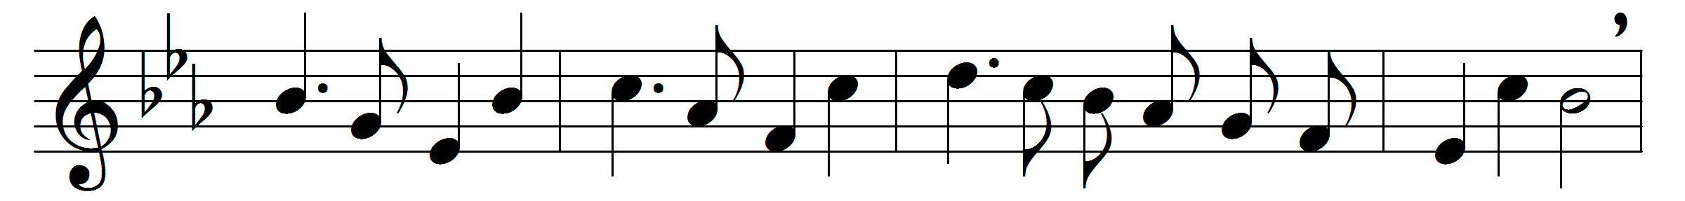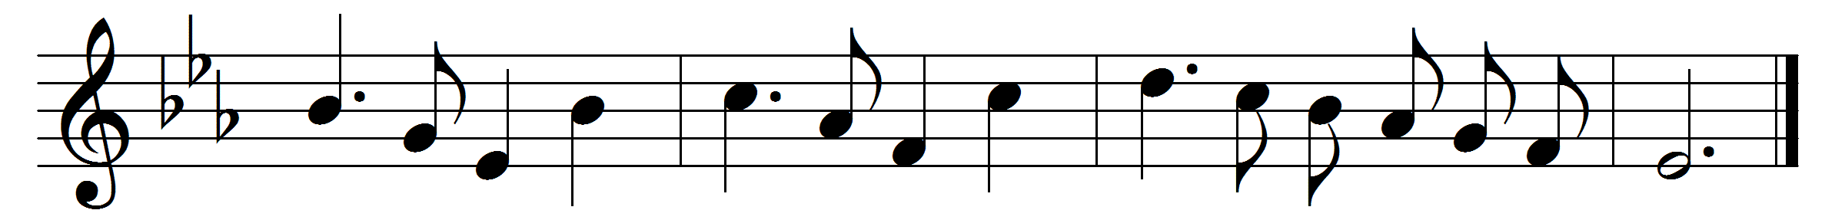

Give me joy in my heart, keep me praising,
give me joy in my heart, I pray;
give me joy in my heart, keep me praising,
keep me praising till the break of day:
Refrain:
Sing hosanna, sing hosanna,
sing hosanna to the King of kings!
Sing hosanna, sing hosanna,
sing hosanna to the King!
Give me peace in my heart, keep me loving,
give me peace in my heart, I pray;
give me peace in my heart, keep me loving,
keep me loving till the break of day:
Refrain
Give me love in my heart, keep me serving,
give me love in my heart, I pray;
give me love in my heart, keep me serving,
keep me serving till the break of day:
Refrain
Words: Traditional
Music: Traditional

