Come, let us with our Lord arise AMNS 449 Melody: Ascendit Deus 8 8 8. D.
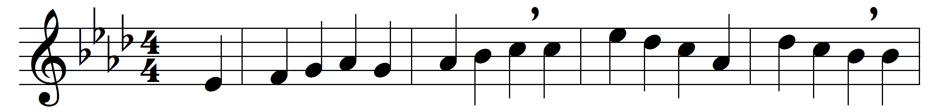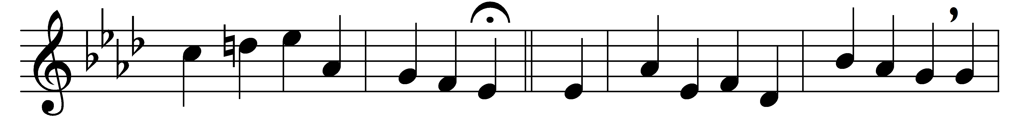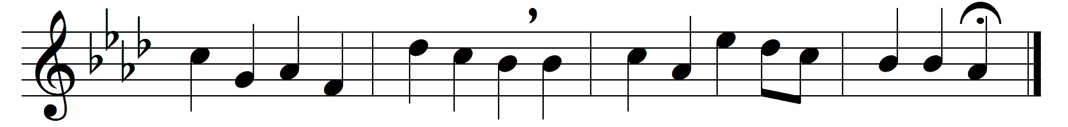

Come, let us with our Lord arise,
our Lord who made both earth and skies,
and gave men gifts of life and peace;
he died to save the world he made,
he rose triumphant from the dead;
and stamped the day forever his.
This is the day the Lord has made,
that all may see his power displayed,
be filled with all the life of God;
may feel his resurrection’s power,
and rise again, to fall no more,
in perfect righteousness renewed.
Then let us render him his own,
with solemn prayer approach his throne,
our joyful hearts and voices raise;
with meekness hear the gospel word,
with thanks his dying love record,
and fill his courts with songs of praise.

Words: Charles Wesley (1707-1788)
Music: Melody by Johann Gottfried Schicht (1753-1823)

