Christ is the heavenly food that gives AMNS 439 Melody: Jackson C.M.
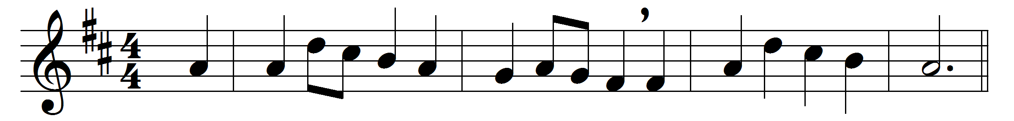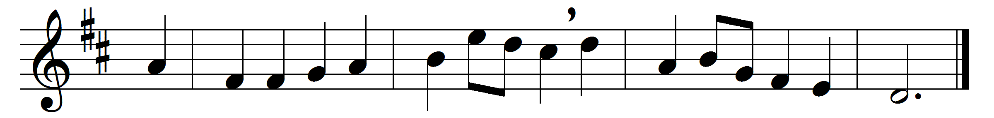

Christ is the heavenly food that gives
to every famished soul
new life and strength, new joy and hope,
and faith to make them whole.
We all are made for God alone,
without him we are dead;
no food suffices for the soul,
but Christ, the living bread.
Christ is the unity that binds
in one the near and far;
for we who share his life divine
his living body are.
On earth and in the realms beyond
one fellowship are we;
and at his altar we are knit
in mystic unity.

Words: Timothy Rees (1874-1939)
Music: Thomas Jackson (1715-1781)

