Awake, our souls; away, our fears AMNS 436 Melody: St. Petersburg L.M.
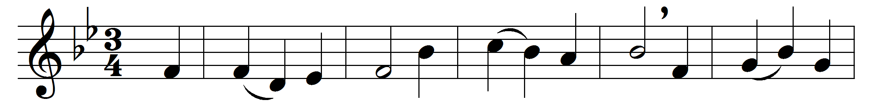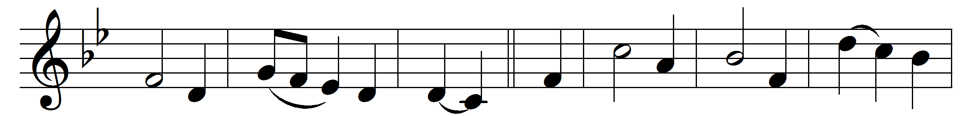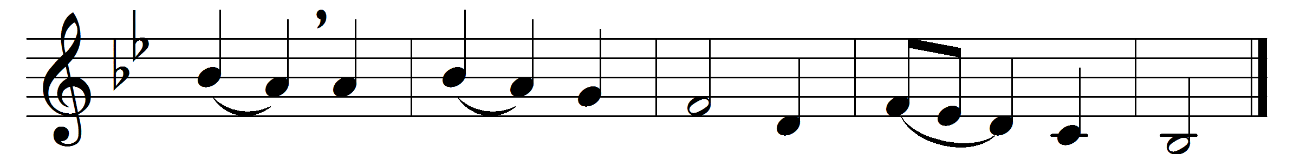

Awake, our souls; away, our fears;
let every trembling thought be gone;
awake and run the heavenly race,
and put a cheerful courage on.

True, ’tis a strait and thorny road,
and mortal spirits tire and faint;
but they forget the mighty God
that feeds the strength of every saint:

the mighty God, whose matchless power
is ever new and ever young,
and firm endures, while endless years
their everlasting circles run.

From thee, the overflowing spring,
our souls shall drink a fresh supply,
while such as trust their native strength
shall melt away, and drop, and die.

Swift as an eagle cuts the air,
we’ll mount aloft to thine abode;
on wings of love our souls shall fly,
nor tire amidst the heavenly road.

Words: Isaac Watts (1674-1748)
Music: Dmitry Stepanovich Bortnyansky (1752-1825)

