As Jacob with travel was weary one day AMNS 435
Melody: Jacob’s Ladder 11 11. 11 11. and refrain
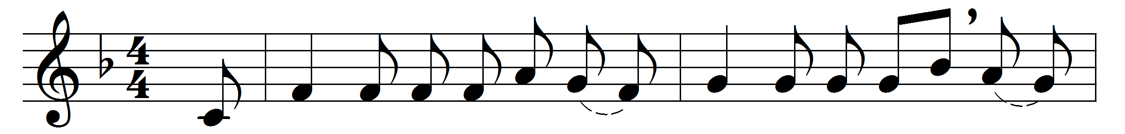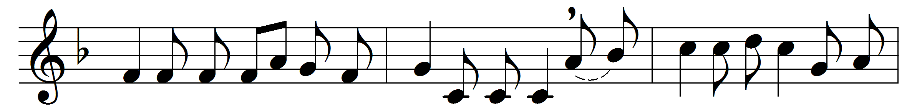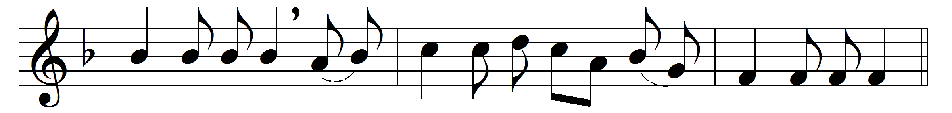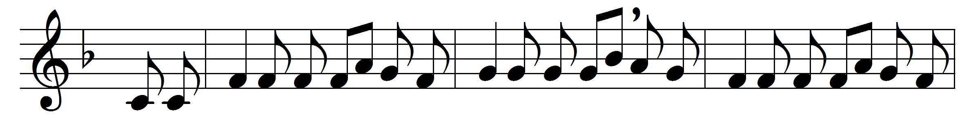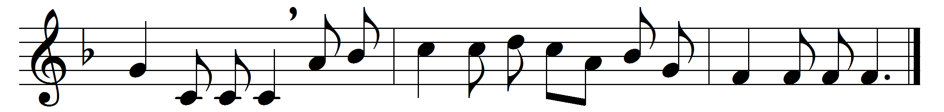

As Jacob with travel was weary one day,
at night on a stone for a pillow he lay;
he saw in a vision a ladder so high
that its foot was on earth and its top in the sky:
(Refrain:) Alleluia to Jesus who died on the tree,
and has raised up a ladder of mercy for me.

This ladder is long, it is strong and well-made,
has stood hundreds of years and is not yet decayed;
many millions have climbed it and reached Sion’s hill;
and thousands by faith are climbing it still:
(Refrain)

Come let us ascend! all may climb it who will;
for the angels of Jacob are guarding it still:
and remember, each step that by faith we pass o’er,
some prophet or martyr has trod it before:
(Refrain)

And when we arrive at the haven of rest
we shall hear the glad words, ‘Come up hither, ye blest,
here are regions of light, here are mansions of bliss’.
O who would not climb such a ladder as this?
(Refrain)

Words: 18th century
Music: English carol melody, 18th century

