Thine be the glory AMNS 428 Melody: Maccabaeus 10 11. 11 11. and refrain

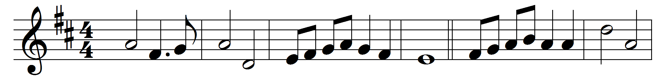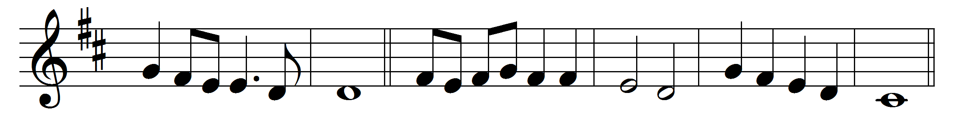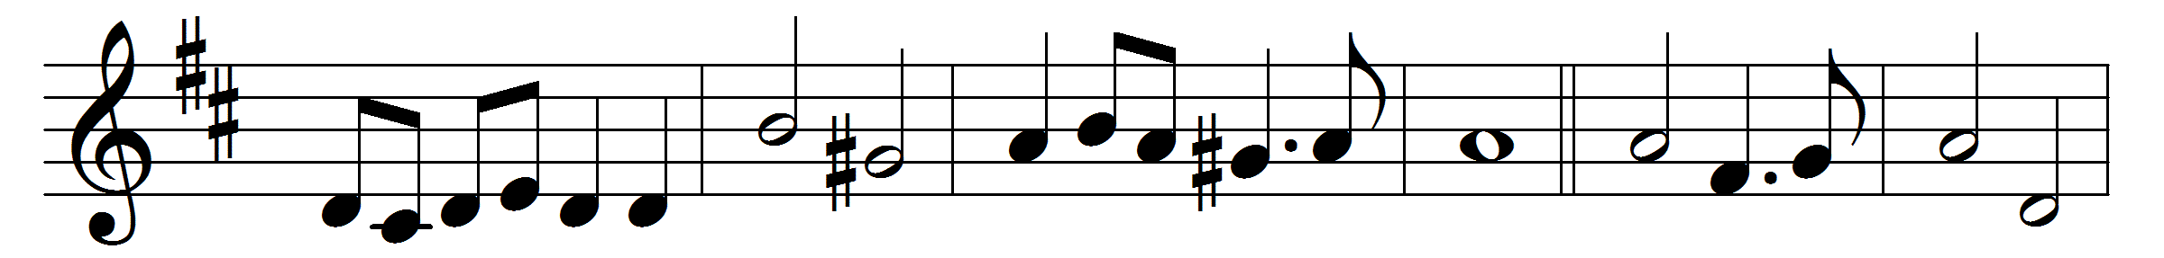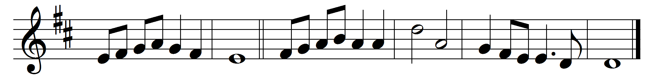

Thine be the glory, risen, conquering Son,
endless is the victory thou o’er death hast won;
angels in bright raiment rolled the stone away,
kept the folded grave-clothes where thy body lay.
(Refrain) Thine be the glory, risen, conquering Son,
endless is the victory thou o’er death hast won.
Lo, Jesus meets us, risen from the tomb;
lovingly he greets us, scatters fear and gloom;
let the Church with gladness hymns of triumph sing,
for her Lord now liveth, death hath lost its sting: [Refrain]
(Refrain)

No more we doubt thee, glorious Prince of Life;
life is nought without thee: aid us in our strife;
make us more than conquerors through thy deathless love;
bring us safe through Jordan to thy home above: [Refrain]
(Refrain)

Words: Edmond Louis Budry (1854-1932), translated by Richard Birch Hoyle (1875-1939)
Music: George Frederick Handel (1685-1759)

