Strengthen for service, Lord, the hands AMNS 421 Melody: Ach Gott und Herr 8 7. 8 7.
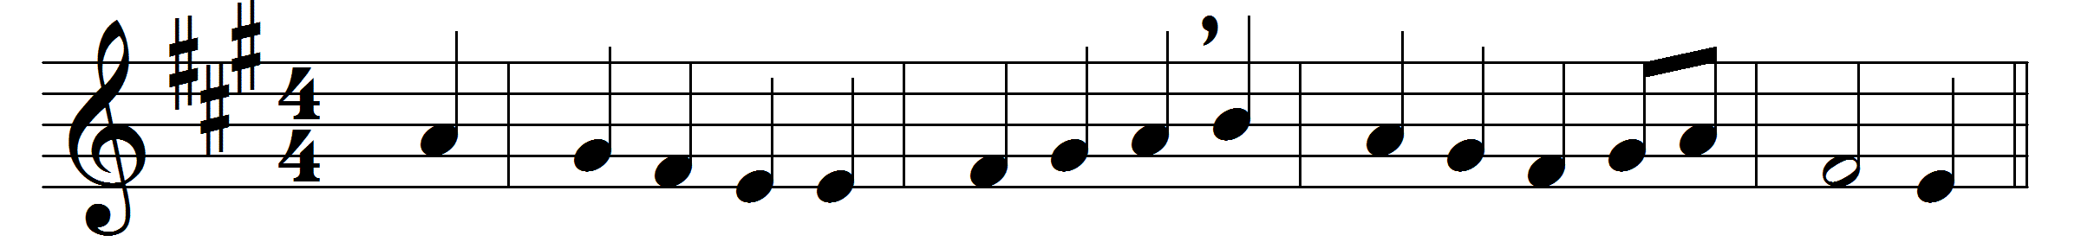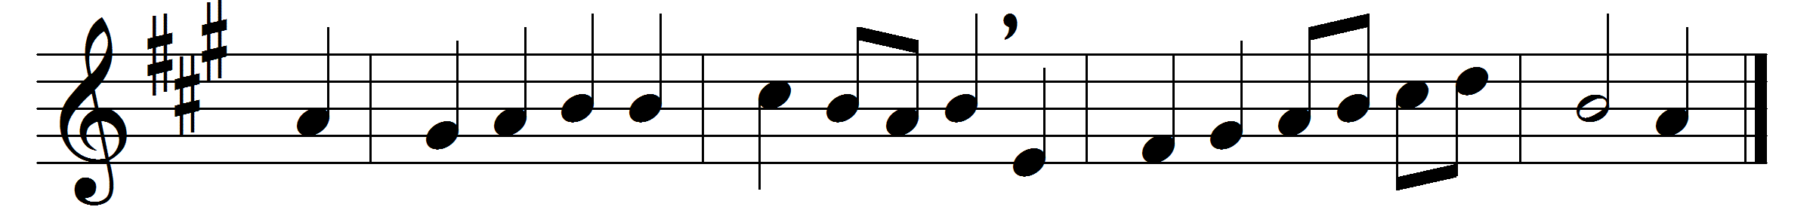

Strengthen for service, Lord, the hands
that holy things have taken;
let ears that now have heard thy songs
to clamour never waken.

Lord, may the tongues which ‘Holy’ sang
keep free from all deceiving;
the eyes which saw thy love be bright,
thy blessèd hope perceiving.

The feet that tread thy holy courts
from light do thou not banish;
the bodies by thy Body fed
with thy new life replenish.

Words: Ascribed to Ephraim the Syrian (c. 306-373), translated by Charles William Humphreys (1841-1921) and Percy Dearmer (1867-1936)
Music: Melody in Neu-Leipziger Gesangbuch (1682), adapted and harmonised by Johann Sebastian Bach (1685-1750)

