It came upon the midnight clear AMNS 41 Melody: Noel D.C.M.
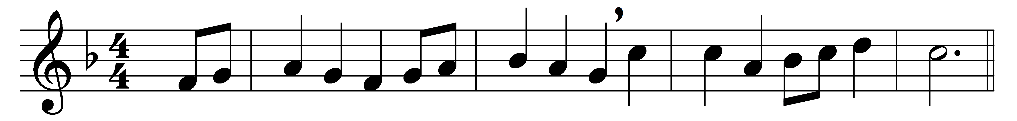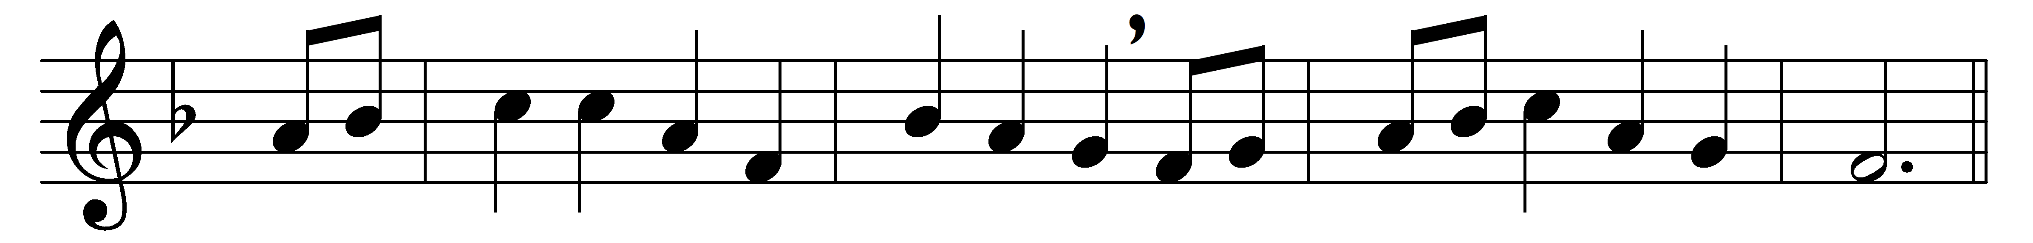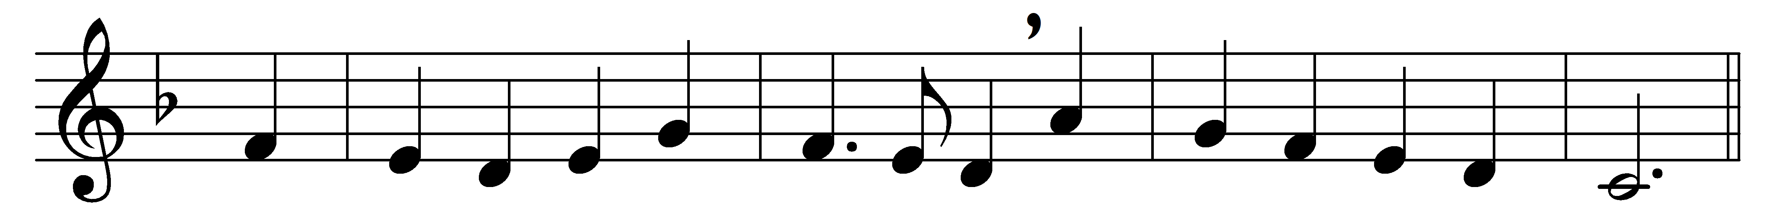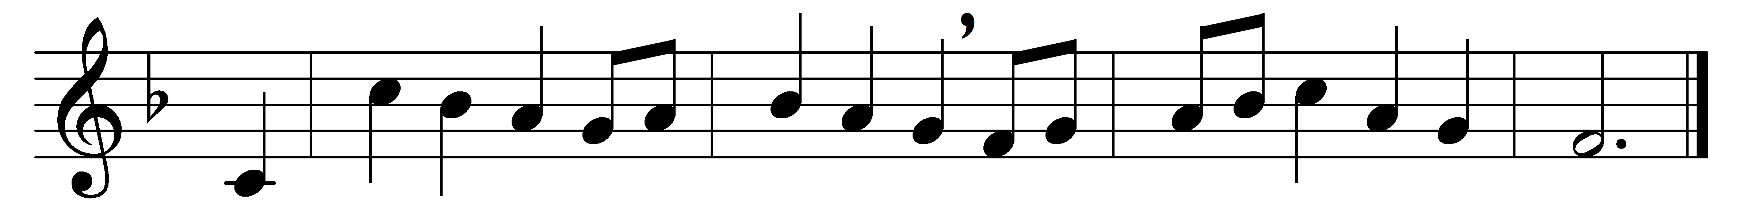

It came upon the midnight clear,
that glorious song of old,
from angels bending near the earth
to touch their harps of gold:
‘Peace on the earth, good will to men,
from heaven’s all-gracious King!’
The world in solemn stillness lay
to hear the angels sing.

Still through the cloven skies they come,
with peaceful wings unfurled;
and still their heavenly music floats
o’er all the weary world:
above its sad and lowly plains
they bend on hovering wing;
and ever o’er its Babel-sounds
the blessèd angels sing.

Yet with the woes of sin and strife
the world has suffered long;
beneath the angel-strain have rolled
two thousand years of wrong;
and man, at war with man, hears not
the love-song which they bring:
O hush the noise, ye men of strife,
and hear the angels sing.

And ye, beneath life’s crushing load,
whose forms are bending low,
who toil along the climbing way
with painful steps and slow,
look, now! for glad and golden hours
come swiftly on the wing;
O rest beside the weary road,
and hear the angels sing.

For lo, the days are hastening on,
by prophet-bards foretold,
when, with the ever-circling years,
comes round the age of gold;
when peace shall over all the earth
its ancient splendours fling,
and the whole world give back the song
which now the angels sing.

Words: Edmund Hamilton Sears (1810-1876)
Music: English traditional melody, adapted by Arthur Sullivan (1842-1900)

