Rise up, O men of God AMNS 418 Melody: Falcon Street (Silver Street) S.M.

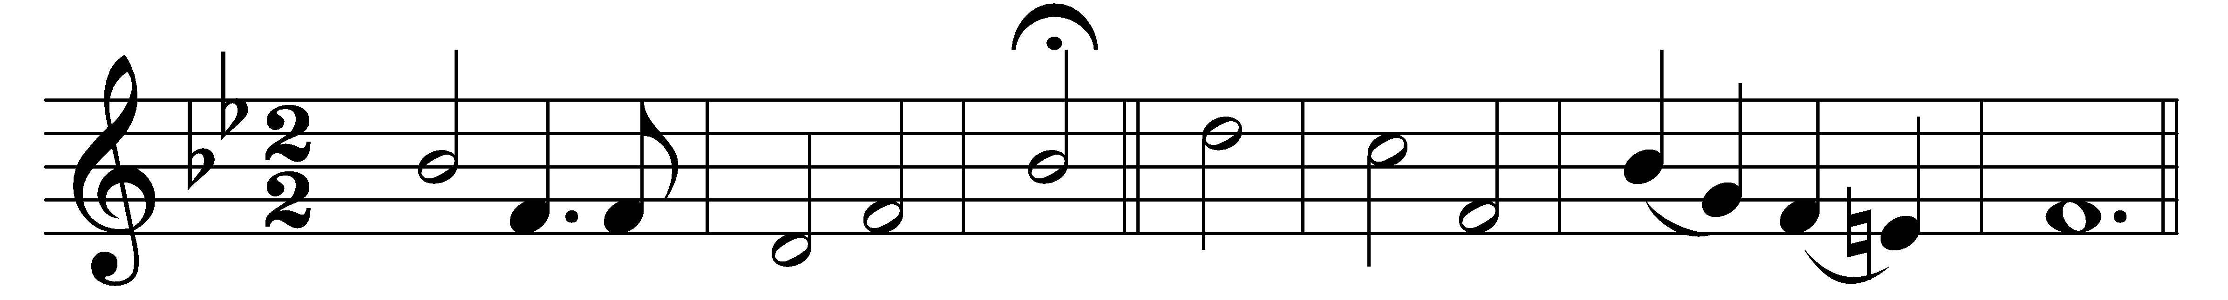

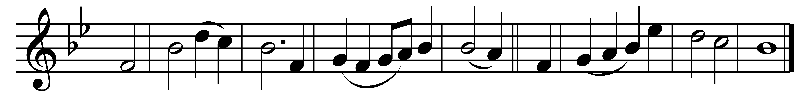

Rise up, O men of God;

have done with lesser things;

give heart and soul and mind and strength

to serve the King of kings.

Rise up, O men of God;

his kingdom tarries long;

bring in the day of brotherhood,

and end the night of wrong.

Rise up, O men of God;

the Church for you doth wait:

her strength unequal to her task;

rise up, and make her great.

Lift high the Cross of Christ;

tread where his feet have trod;

as brothers of the Son of Man

rise up, O men of God.

Words: William Pierson Merrill (1867-1954)

Music: Late form of melody by Isaac Smith (c. 1770)