Praise we now the Word of grace AMNS 83 Melody: Savannah 7 7. 7 7.
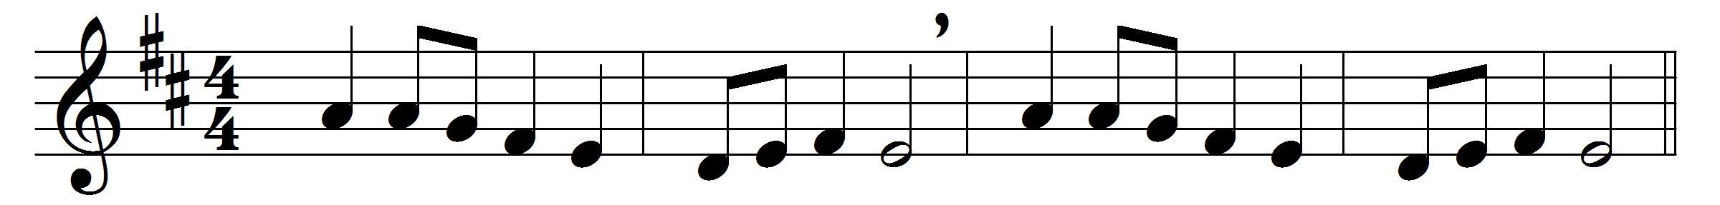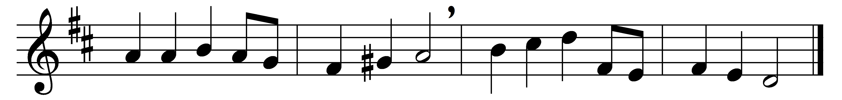

Praise we now the Word of grace;
may our hearts its truth embrace:
from its pages may we hear
Christ our Teacher, speaking clear.
May the Gospel of the Lord
everywhere be spread abroad,
that the world around may own
Christ as King, and Christ alone.

Words: Sydney Newman Sedgwick (1872-1941)
Music: John Wesley’s Foundery Collection, 1742

